Tour ID: 255076  
Tour Name: Northern Lights & Hidden Gems - 8 days

Tour destinations: ['Reykjavik', 'Kirkjubaejarklaustur', 'Hofn', 'Egilsstadir', 'Akureyri', 'Laugarbakki']

Tour destinations images:

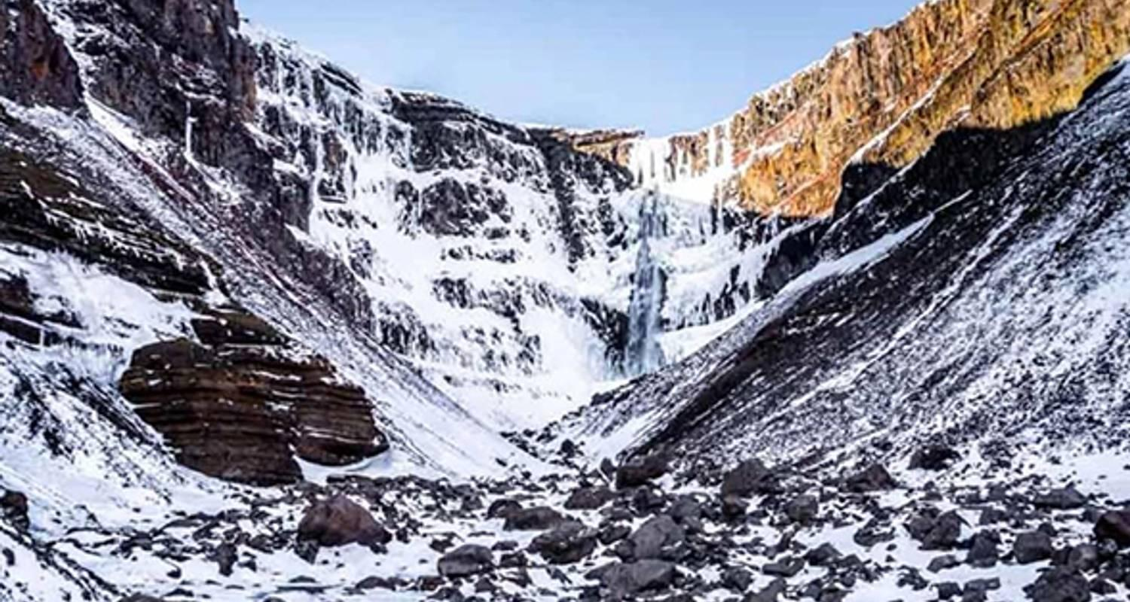

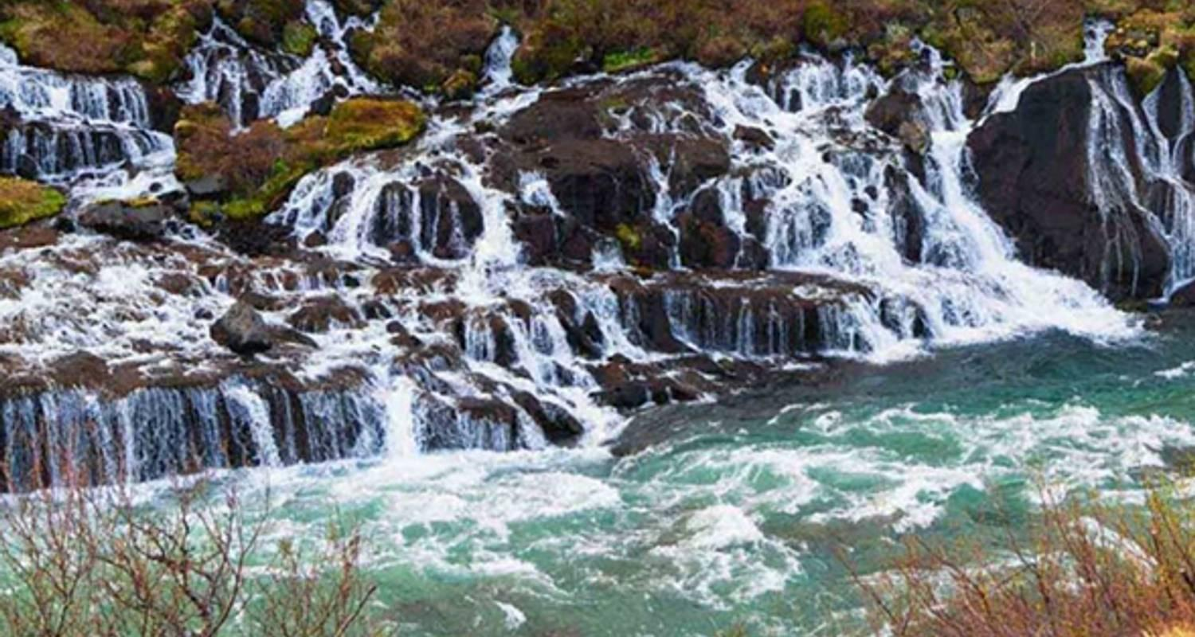

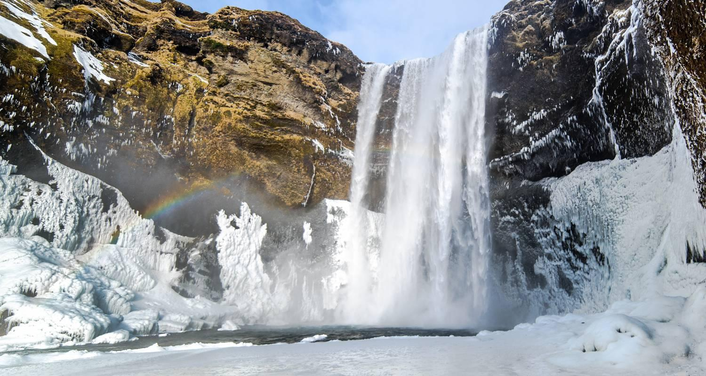

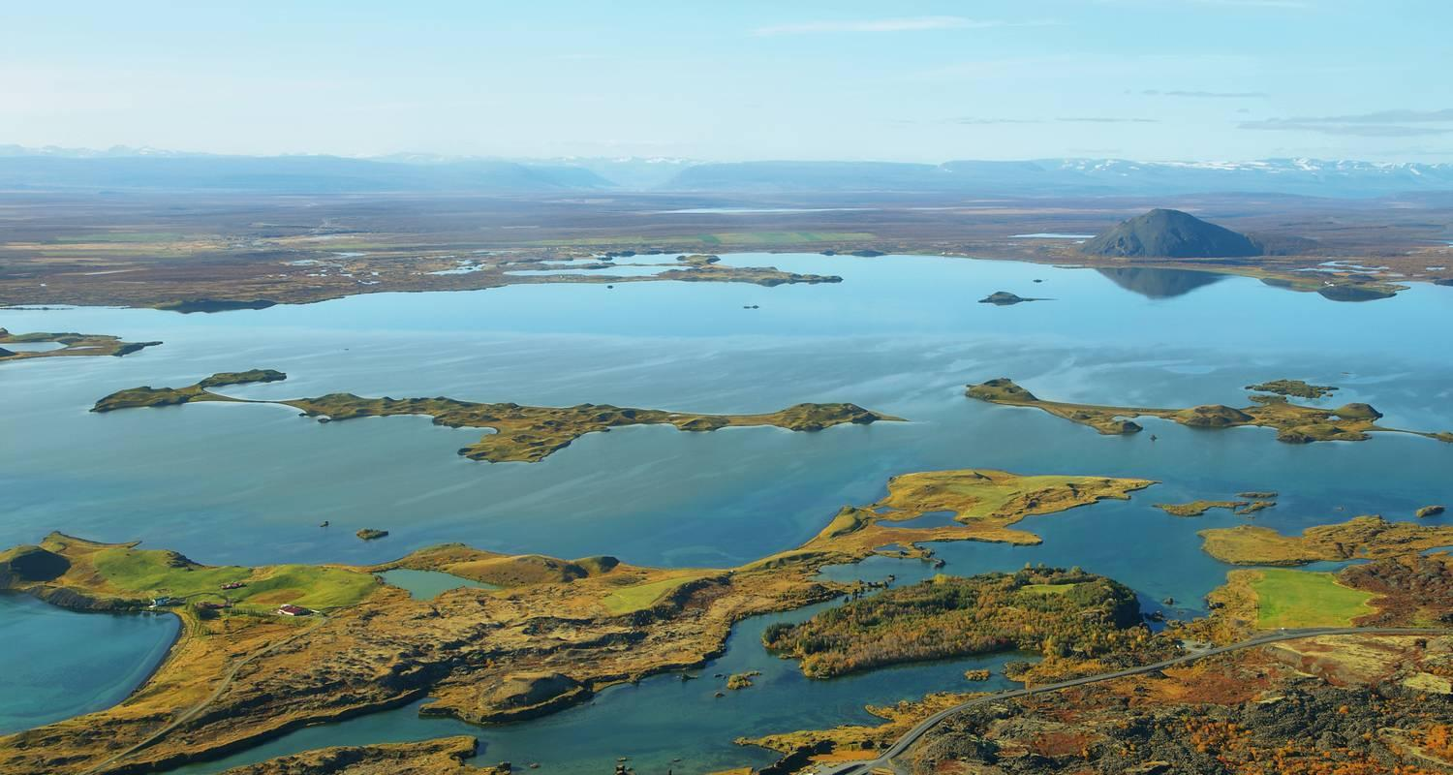

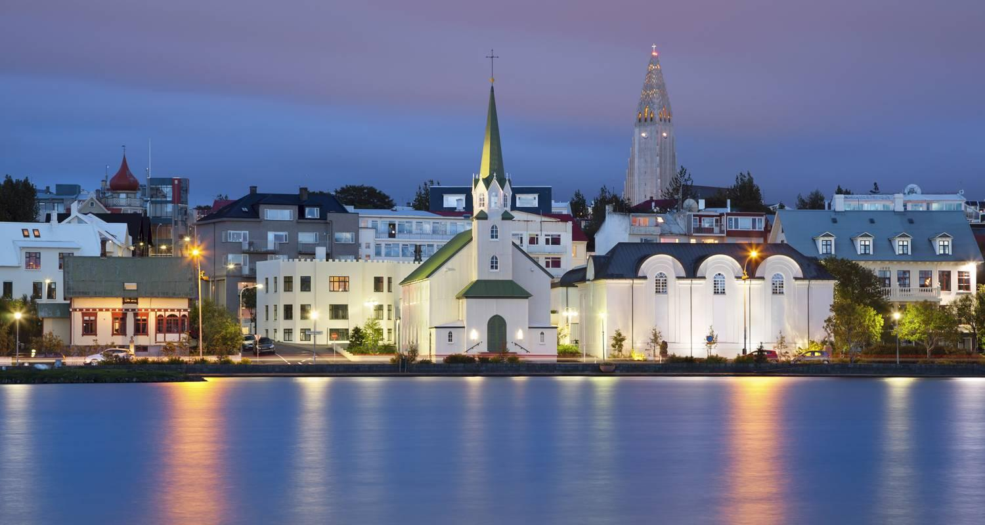

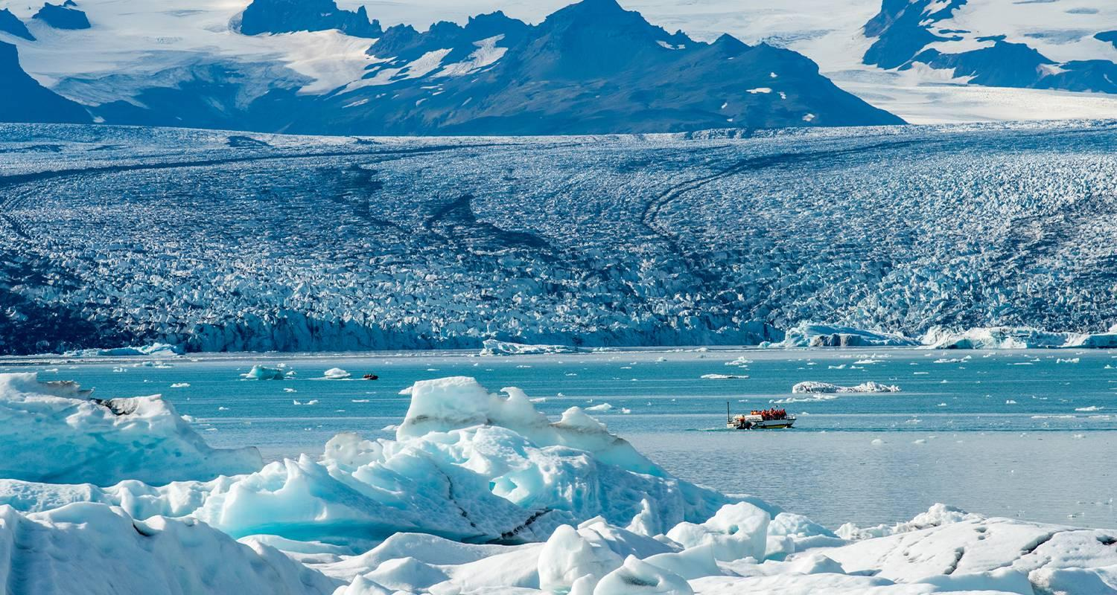

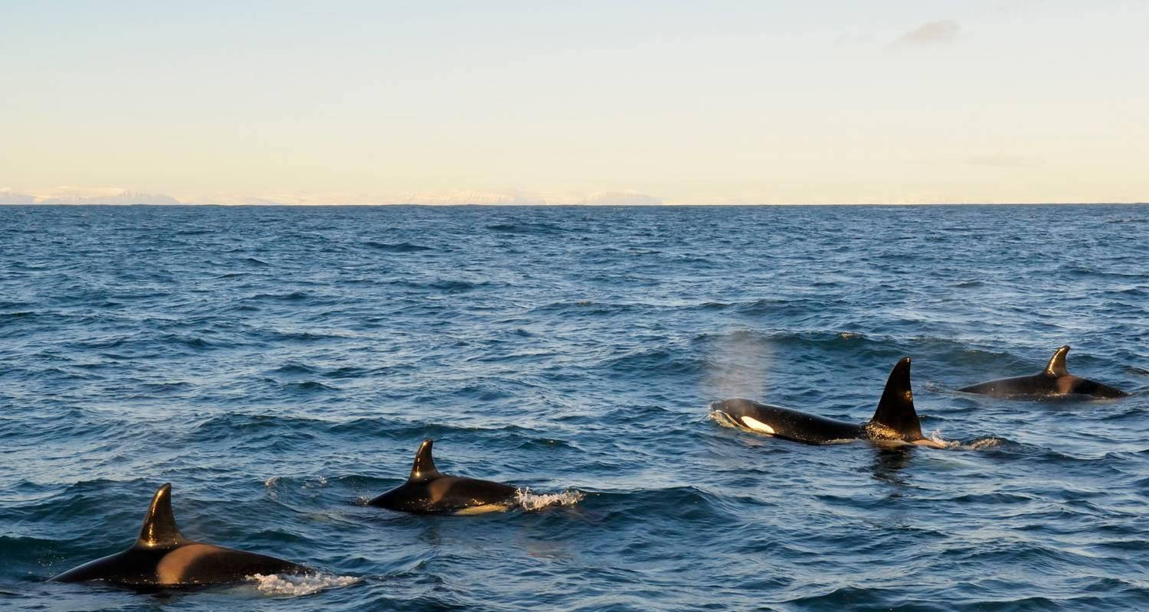

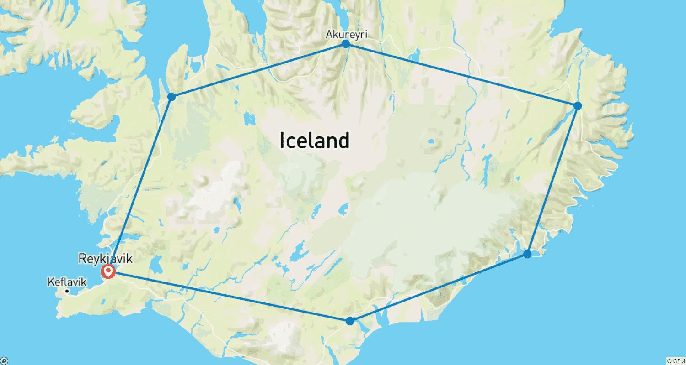

Tour ID: 255641  
Tour Name: Iceland's Classic Northern Lights

Tour destinations: ['Reykjavik', 'Hveragerdi', 'Gunnuhver', 'Grindavik', 'Gullfoss', 'Secret Lagoon', 'Skogafoss', 'Solheimajokull', 'Thingvellir National Park']

Tour destinations images:

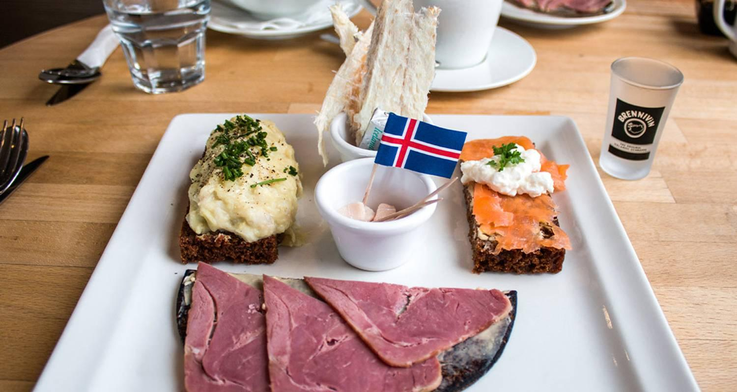

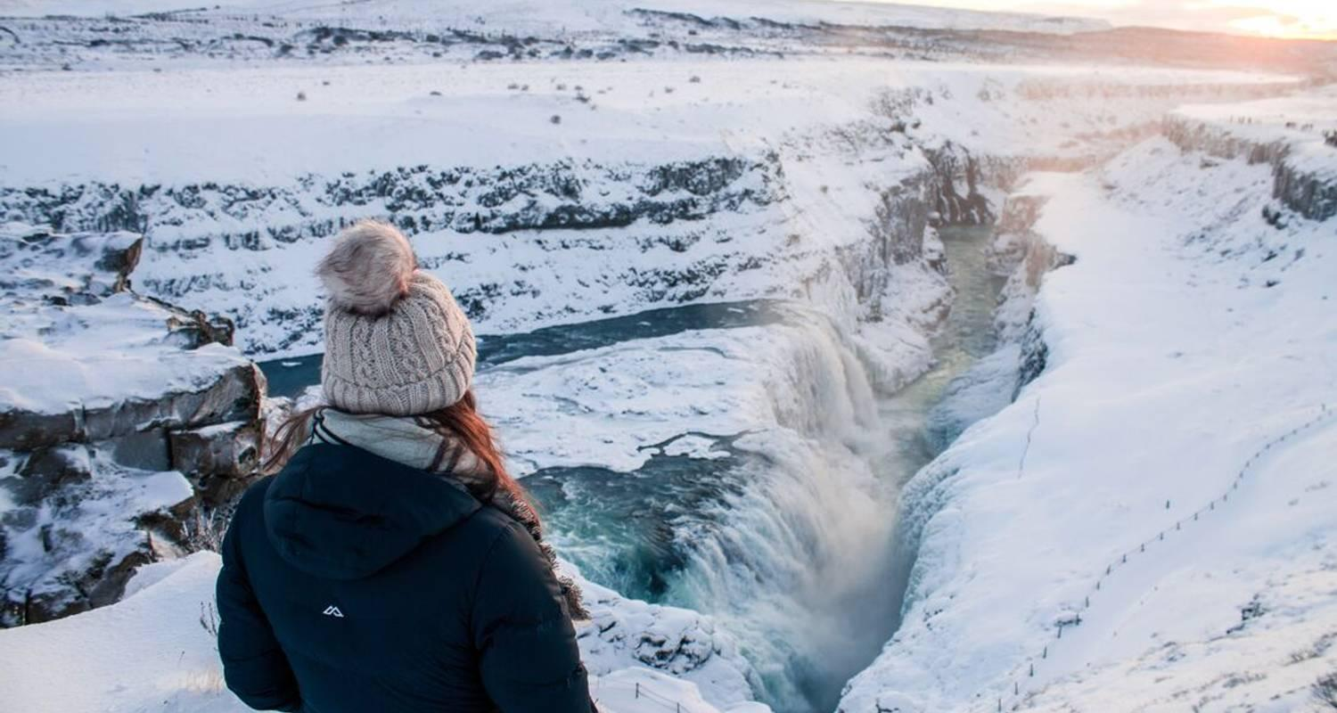

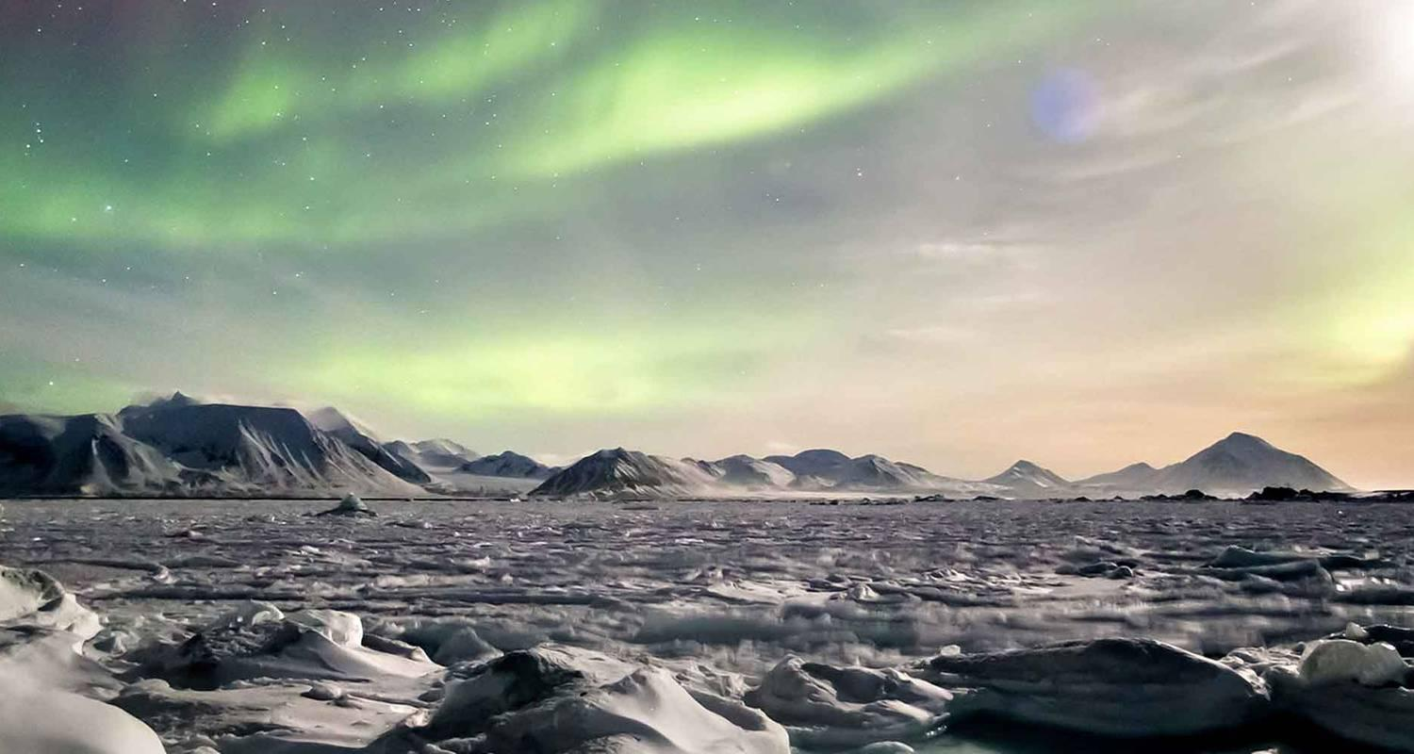

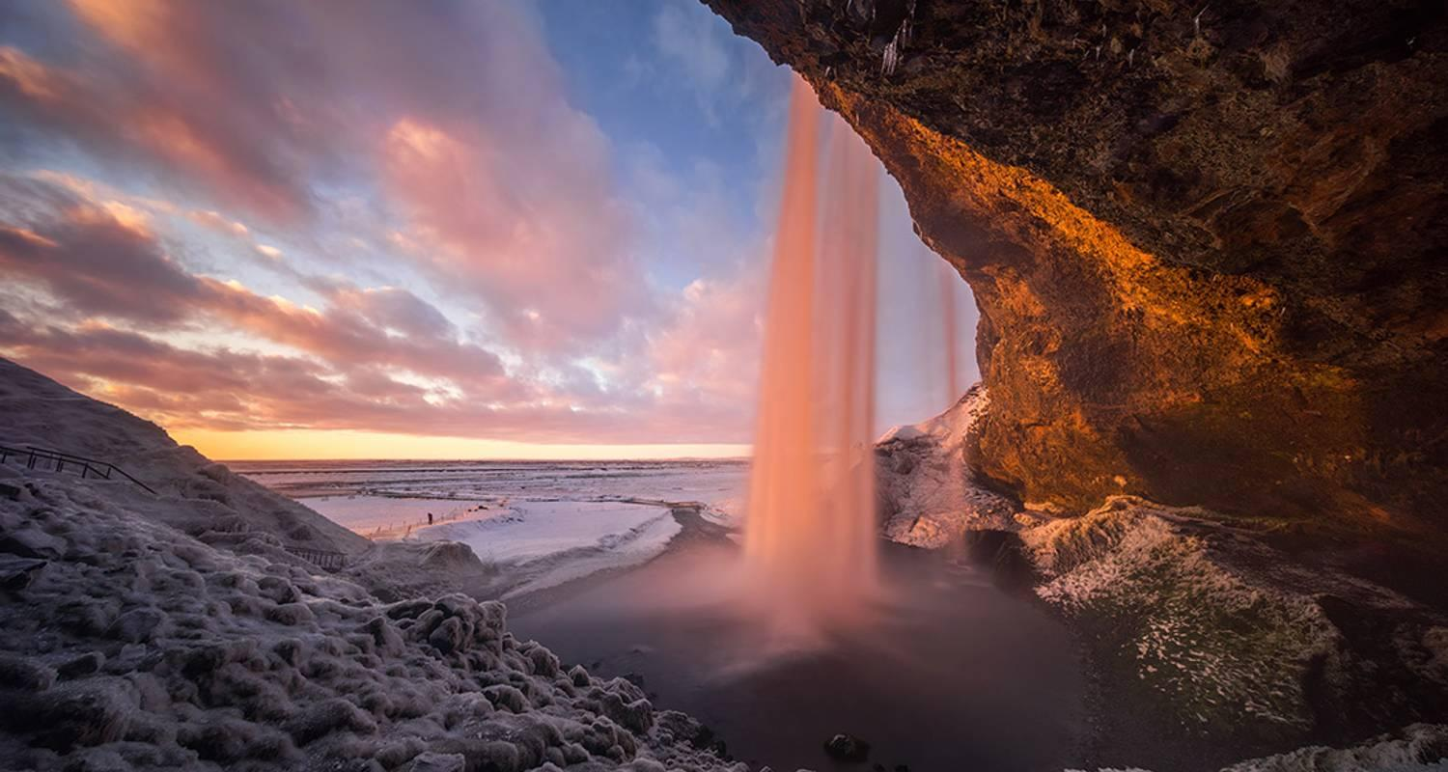

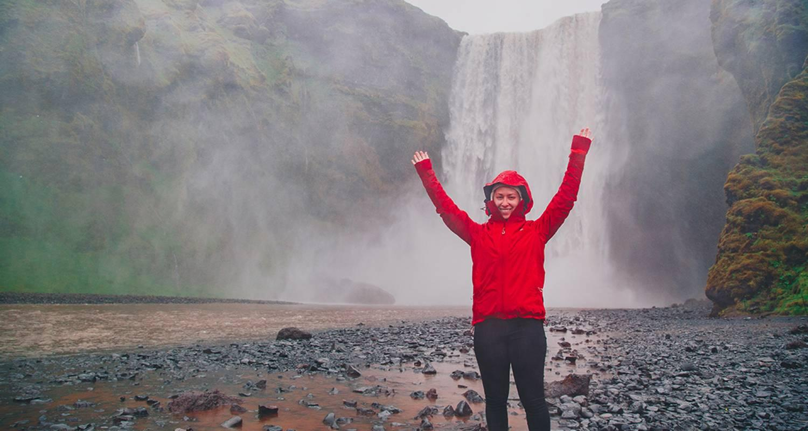

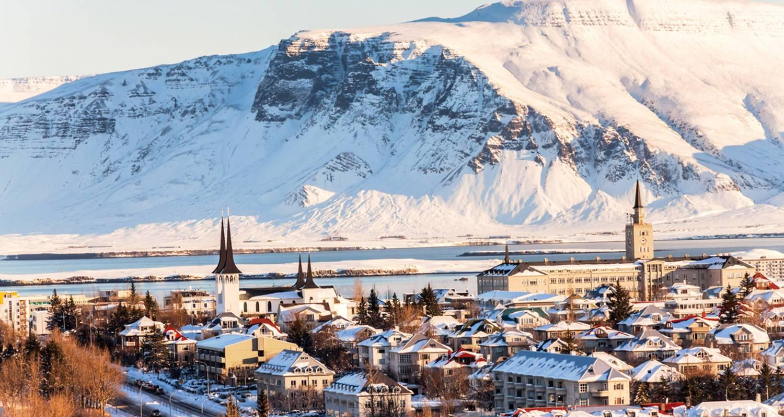

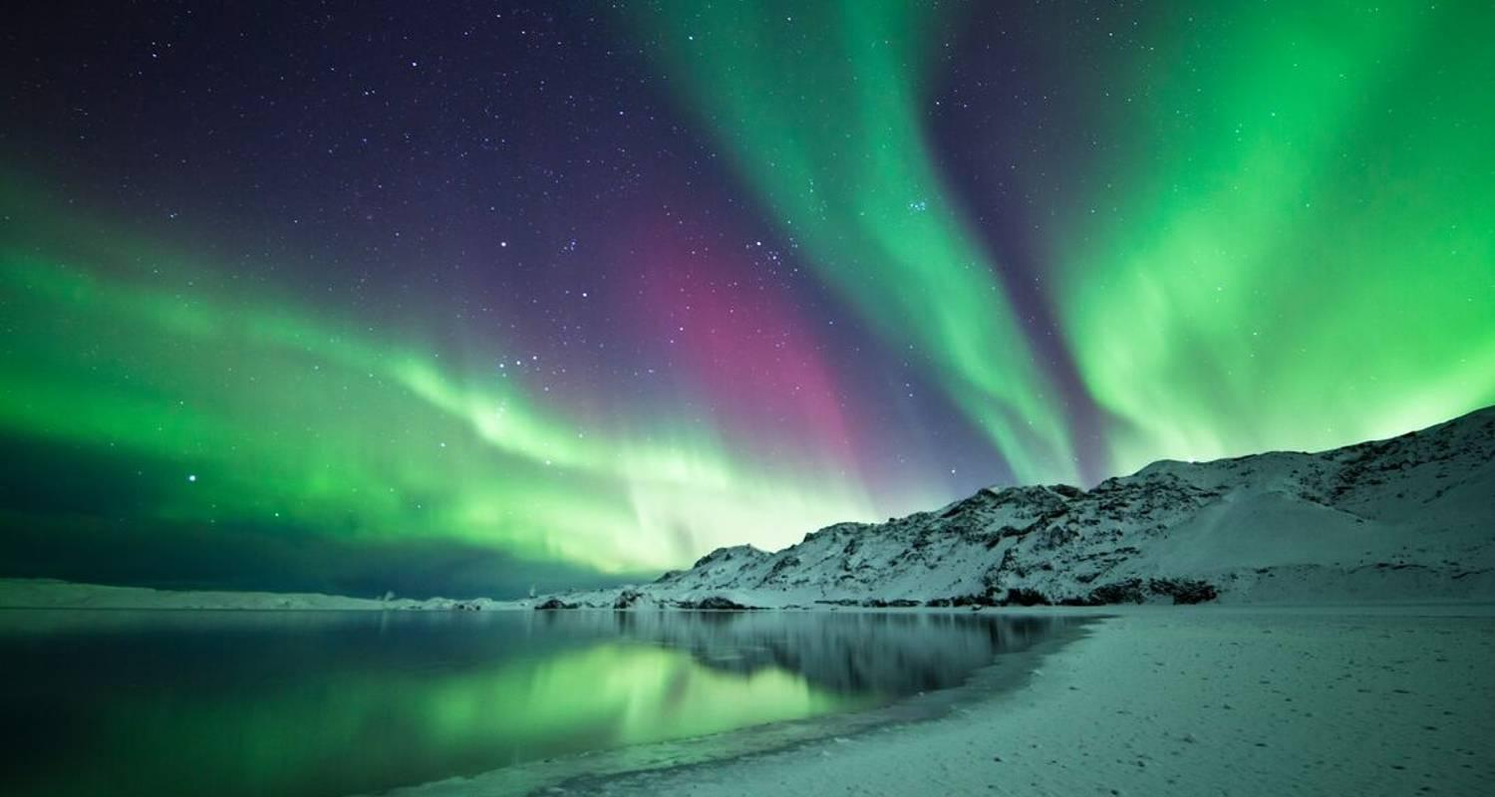

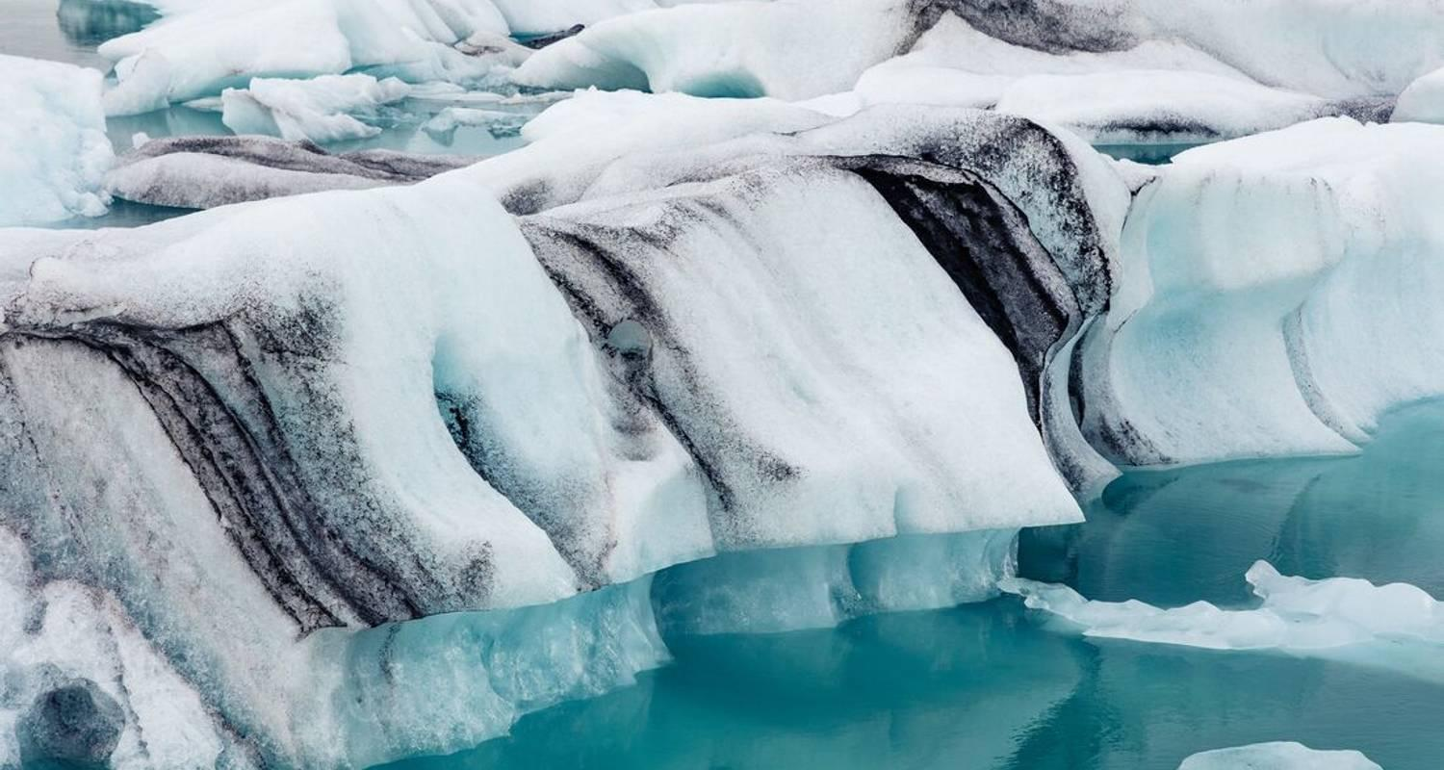

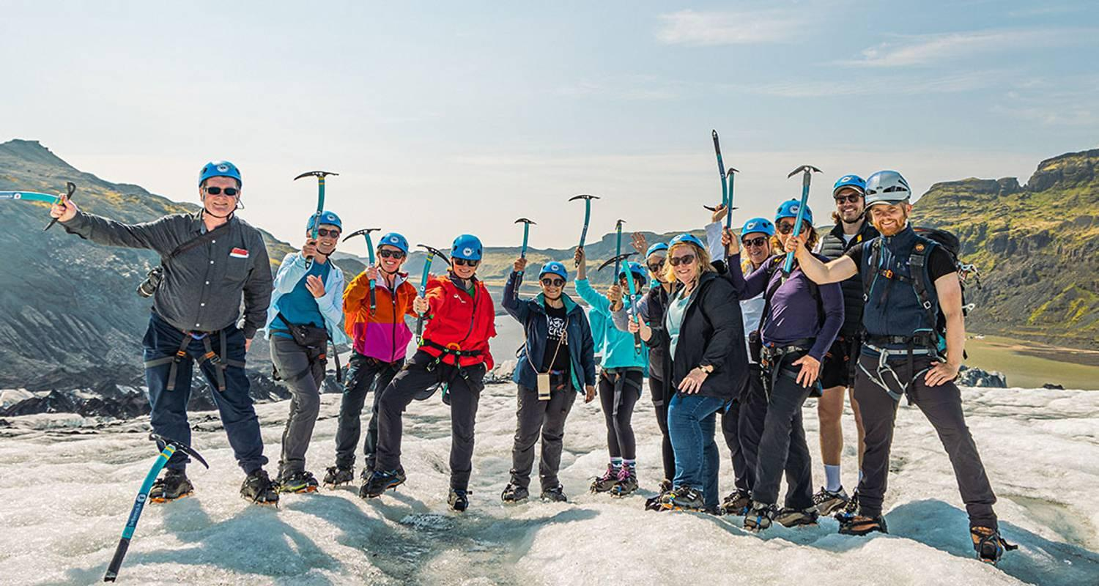

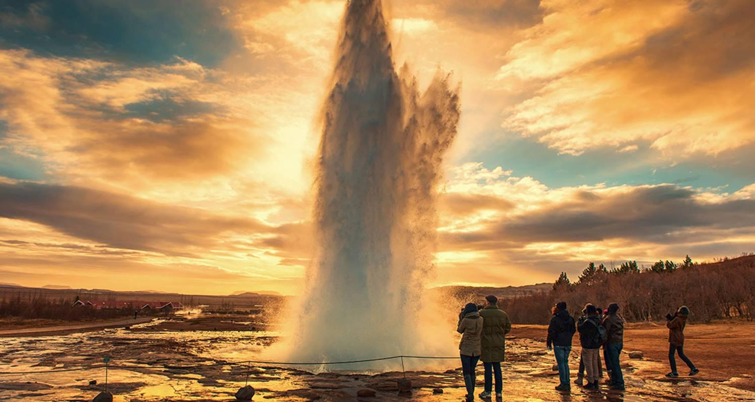

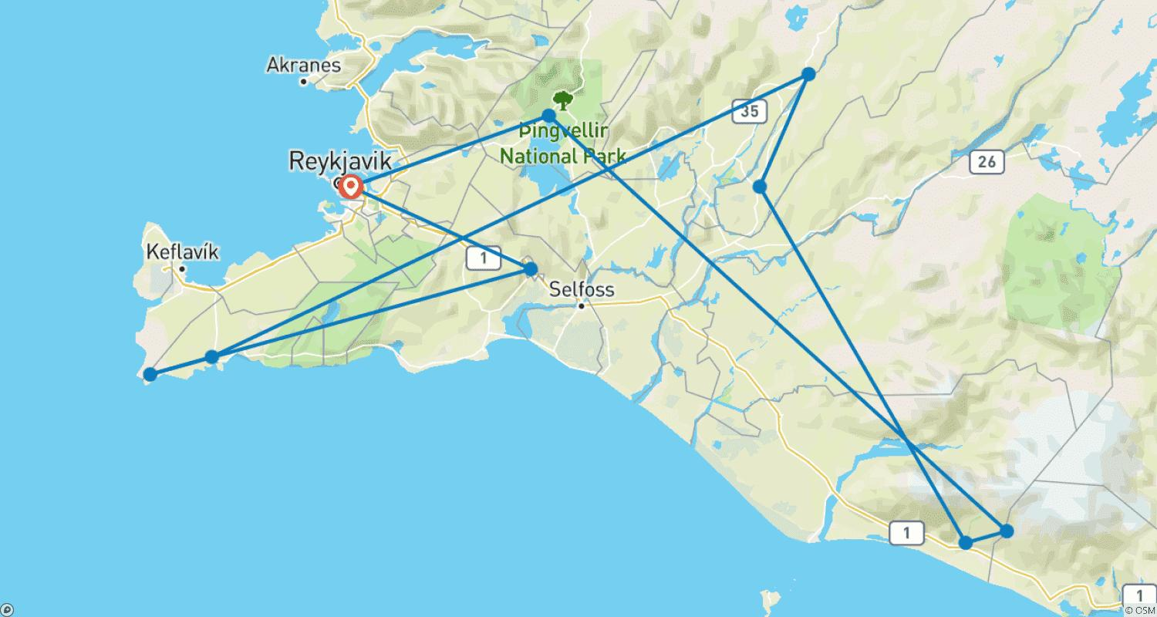

Tour ID: 255955  
Tour Name: Delve Deep: Iceland (Winter)

Tour destinations: ['Reykjavik', 'Thingvellir National Park', 'Secret Lagoon', 'Geysir', 'Skaftafell', 'Reynisfjara', 'Hraunfossar', 'Snæfellsnes', 'Arnarstapi', 'Stykkisholmur']

Tour destinations images:

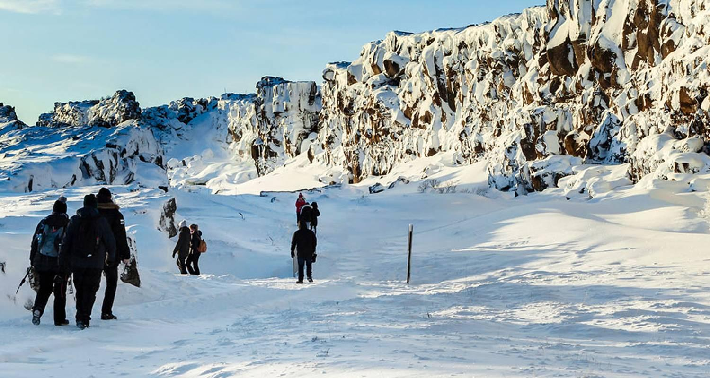

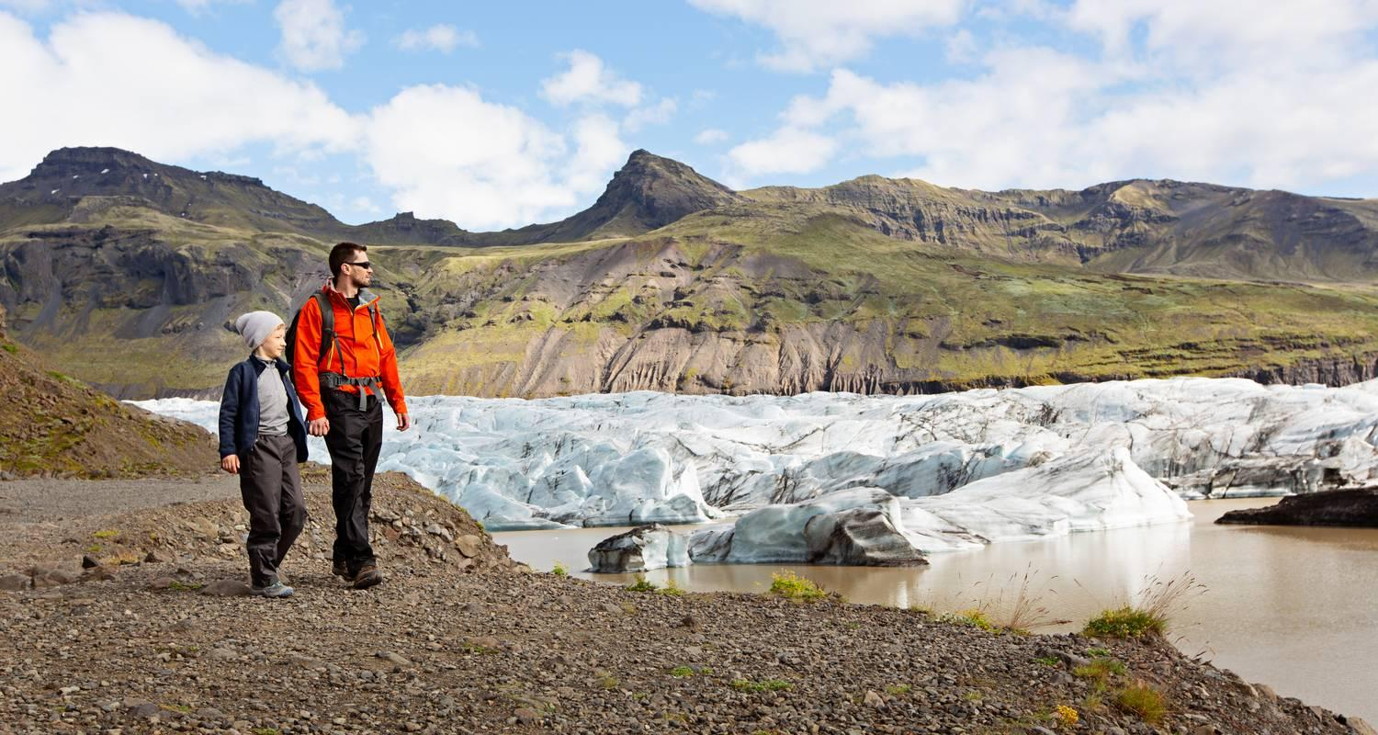

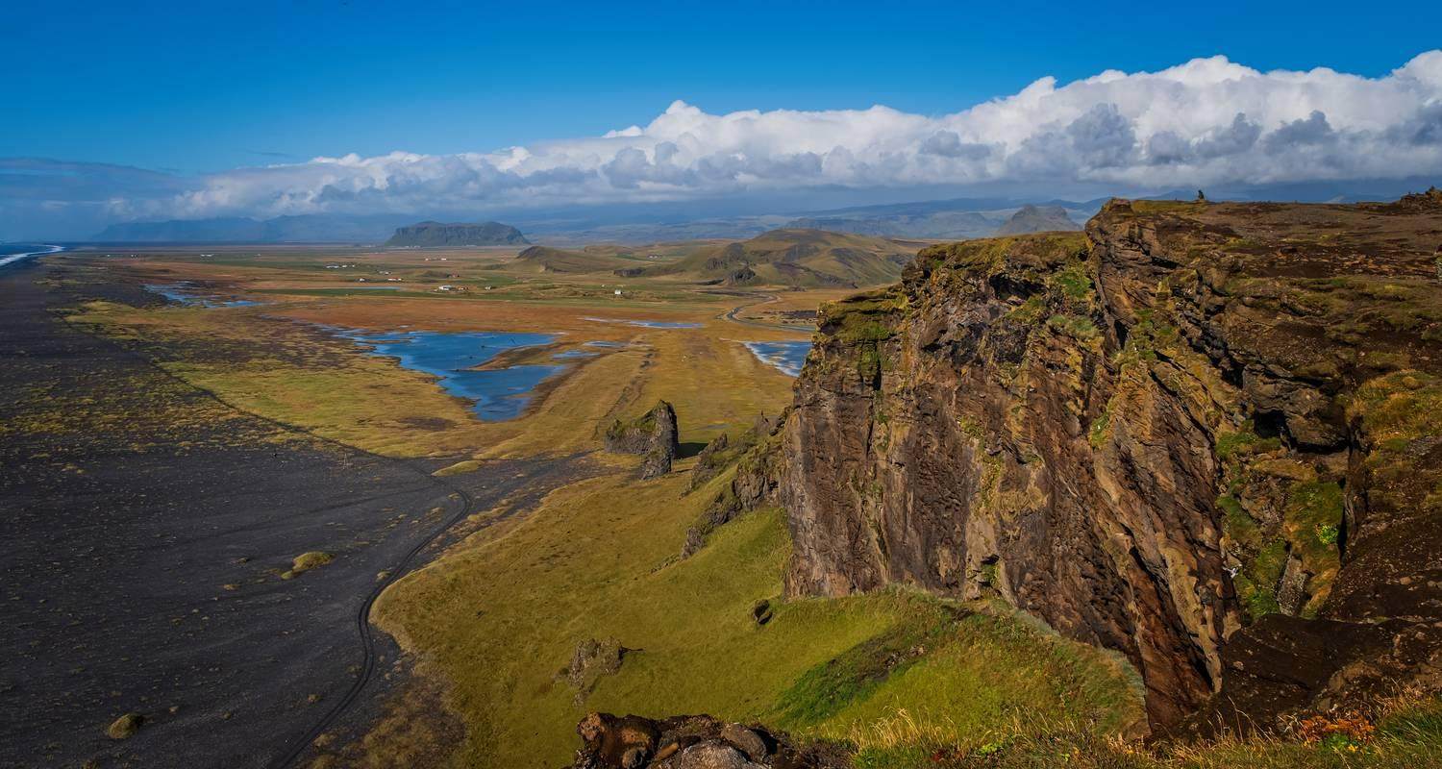

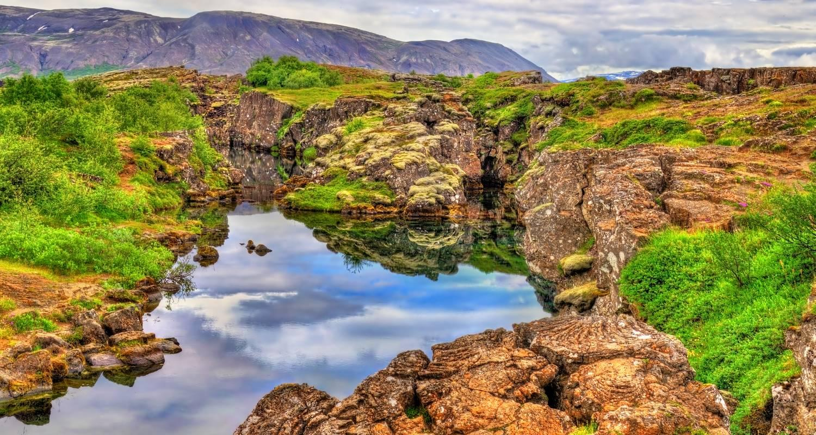

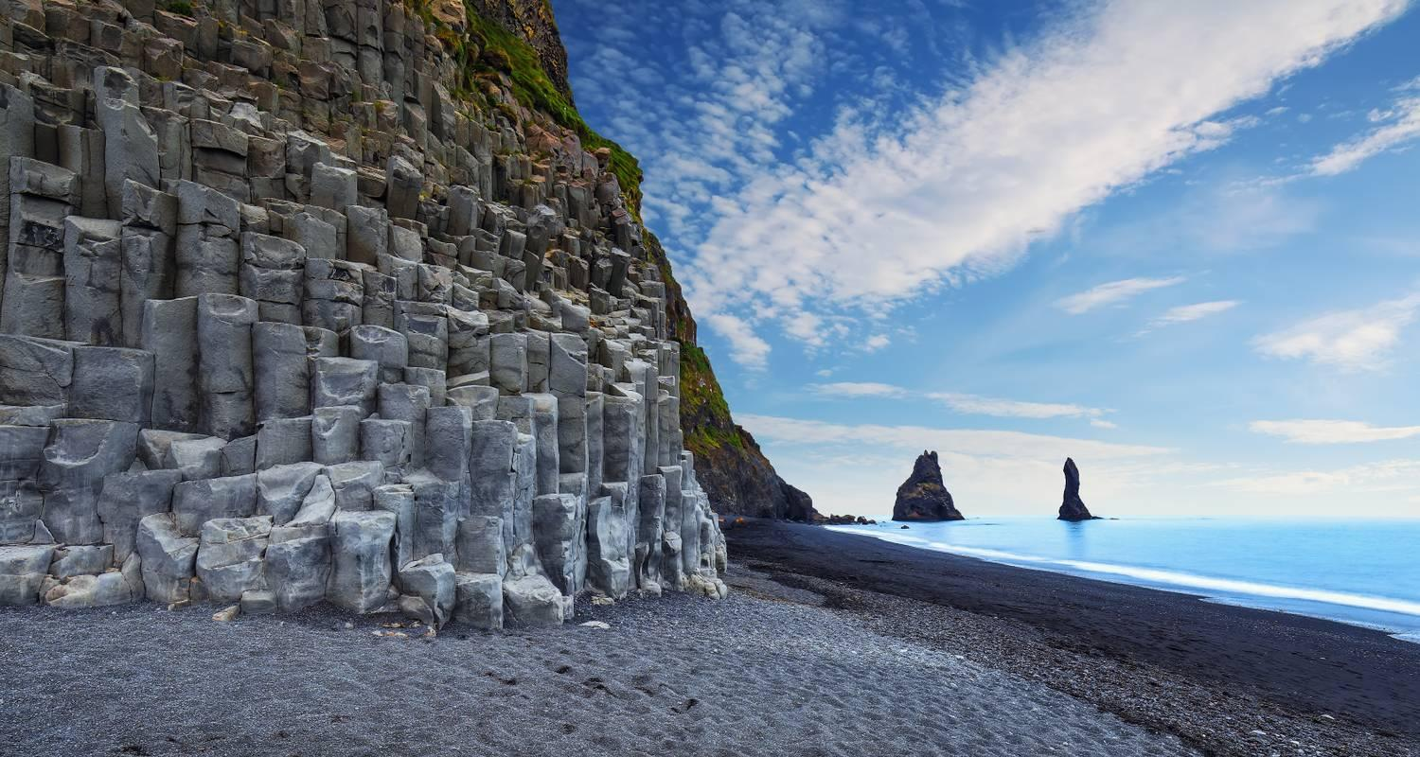

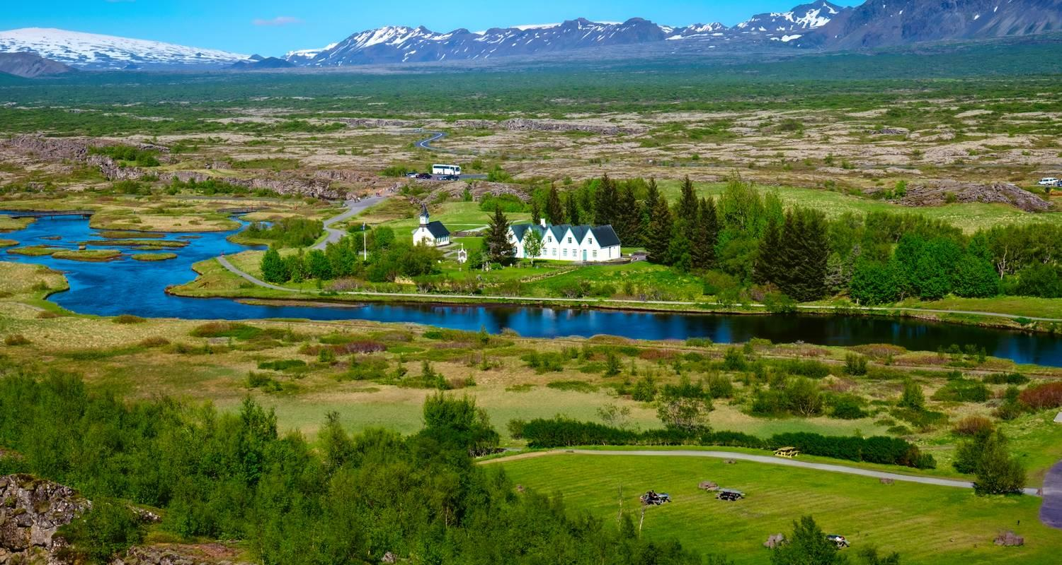

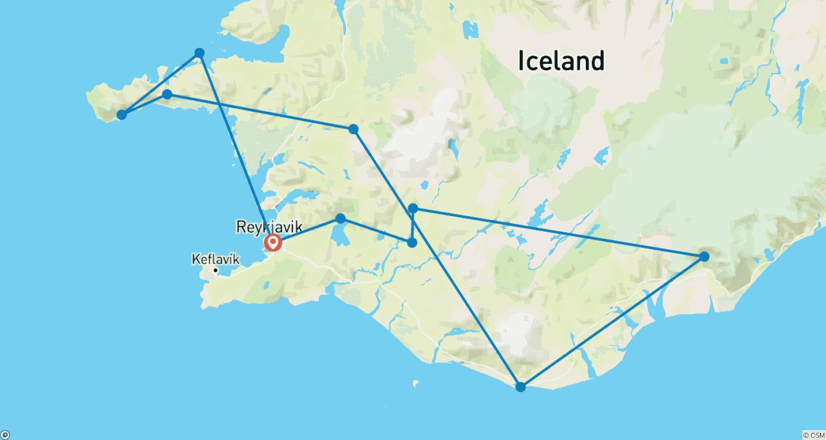

Tour ID: 256325  
Tour Name: Northern Lights Exploration (Small Group) - 8 days

Tour destinations: ['Reykjavik', 'Borgarnes', 'Hraunfossar', 'Arnarstapi', 'Hellnar', 'Hella', 'Thingvellir National Park', 'Geysir', 'Gullfoss', 'Kirkjubaejarklaustur', 'Reynisfjara', 'Vik', 'Blue Lagoon', 'Keflavik']

Tour destinations images:

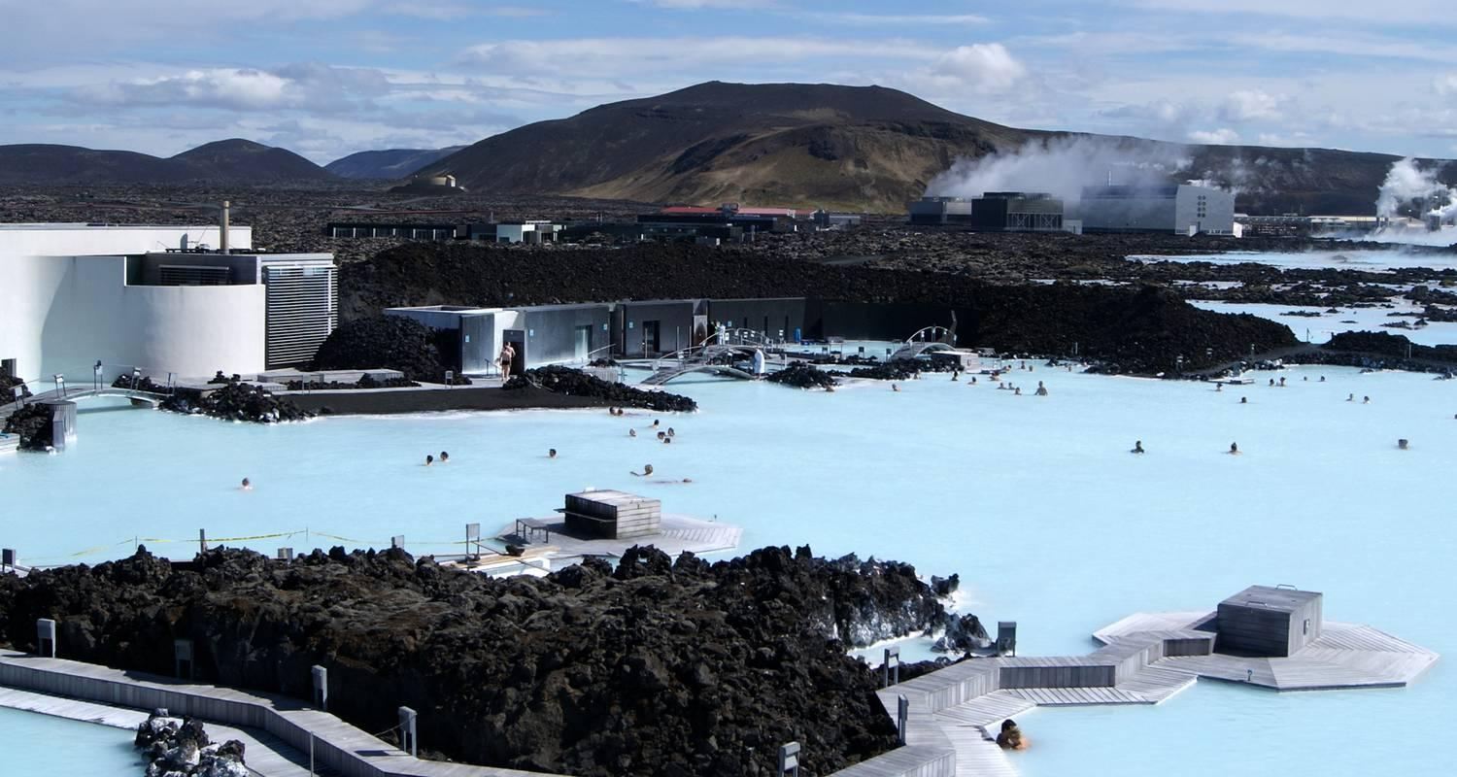

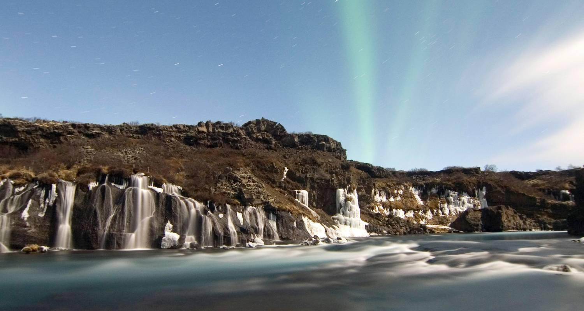

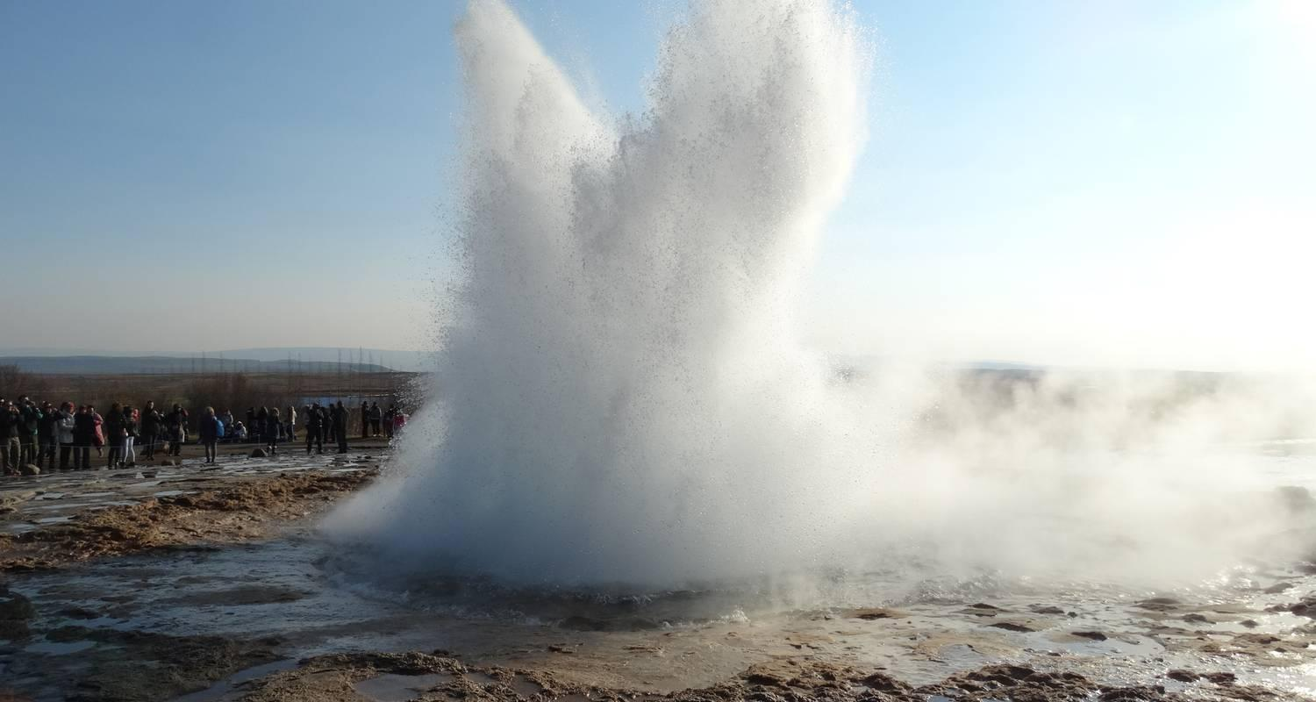

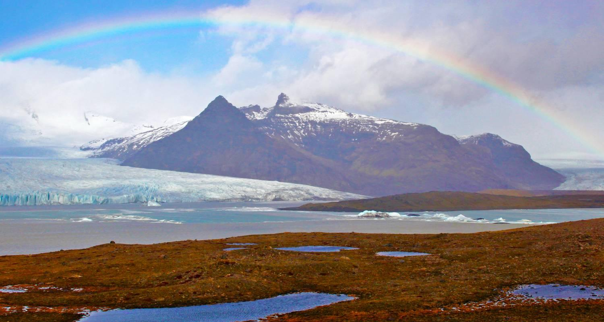

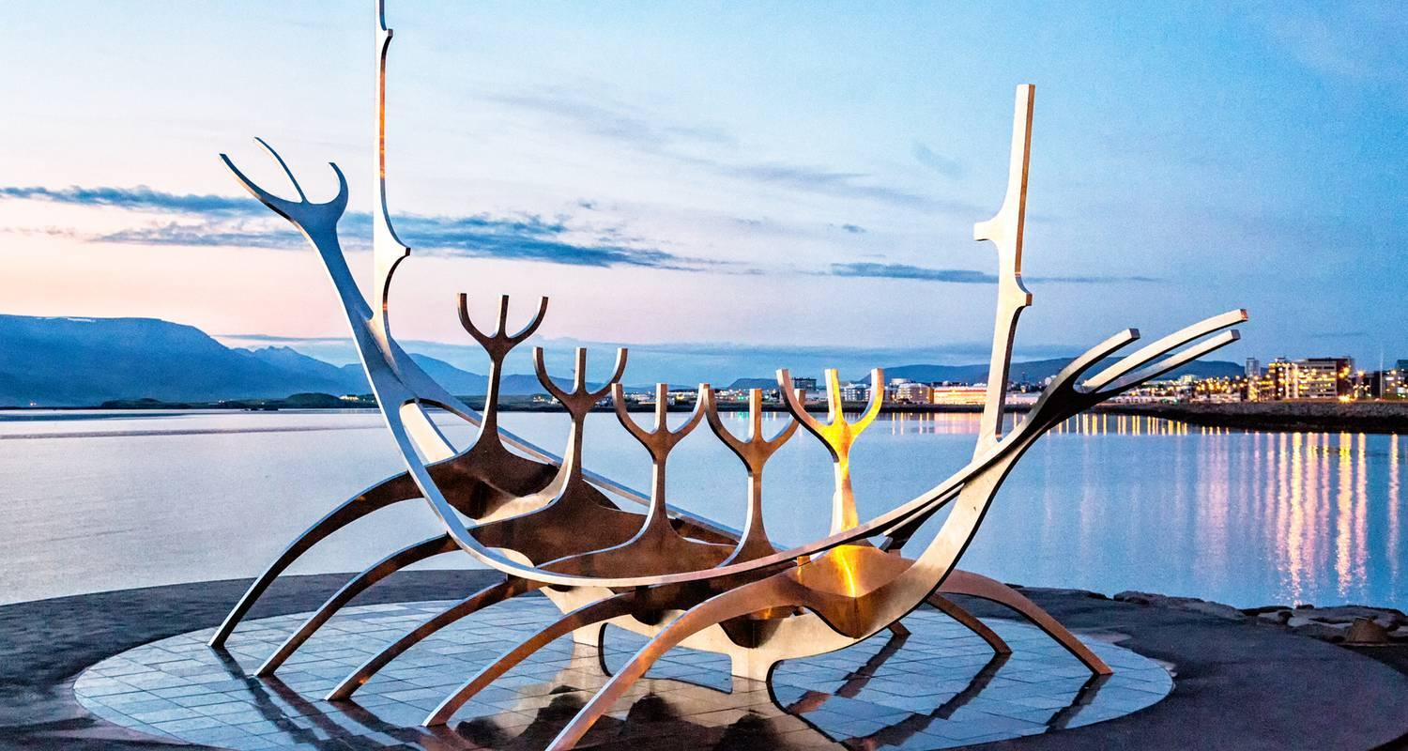

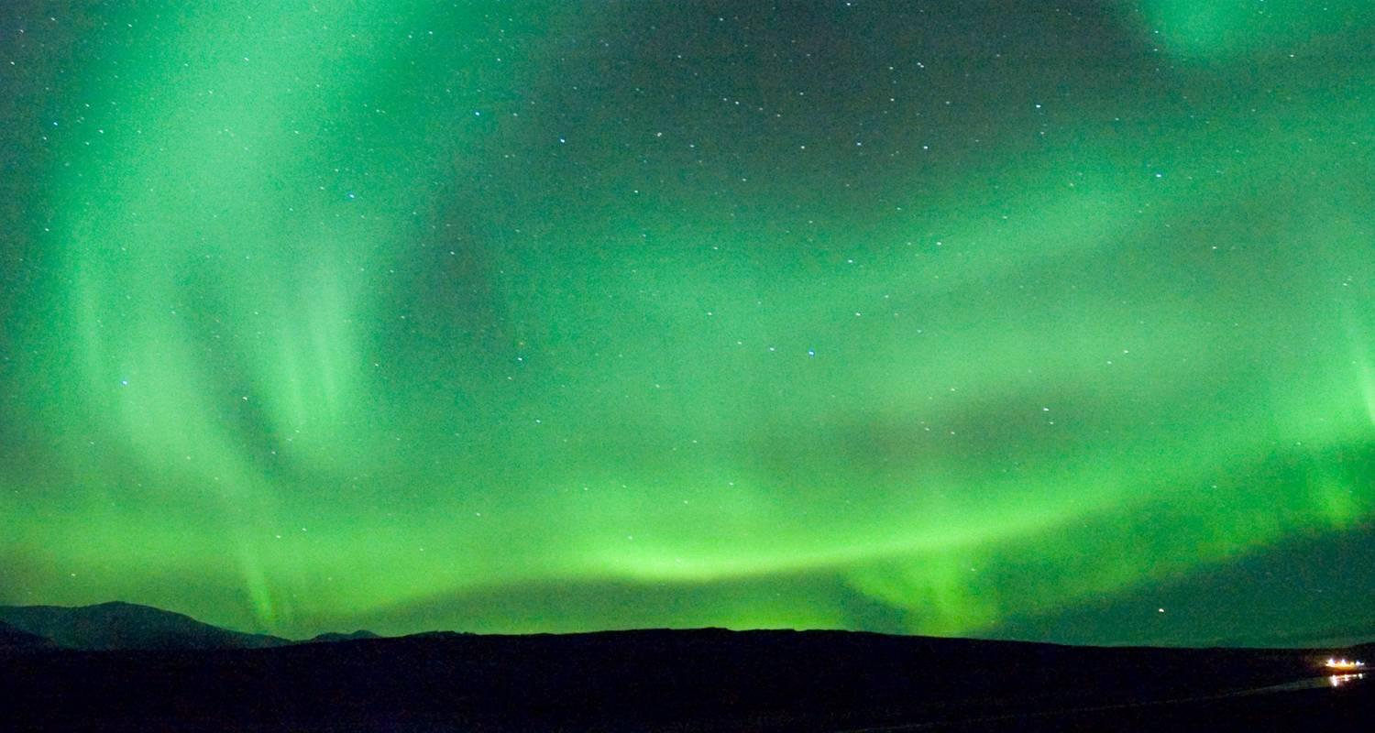

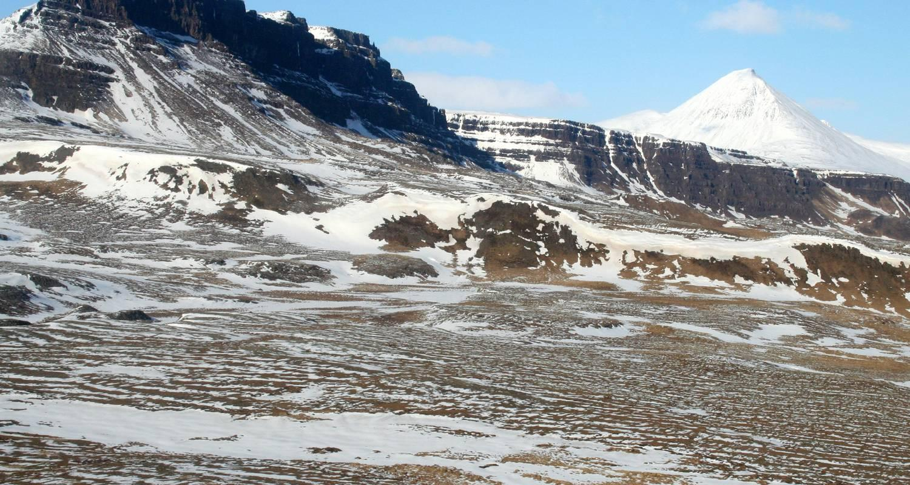

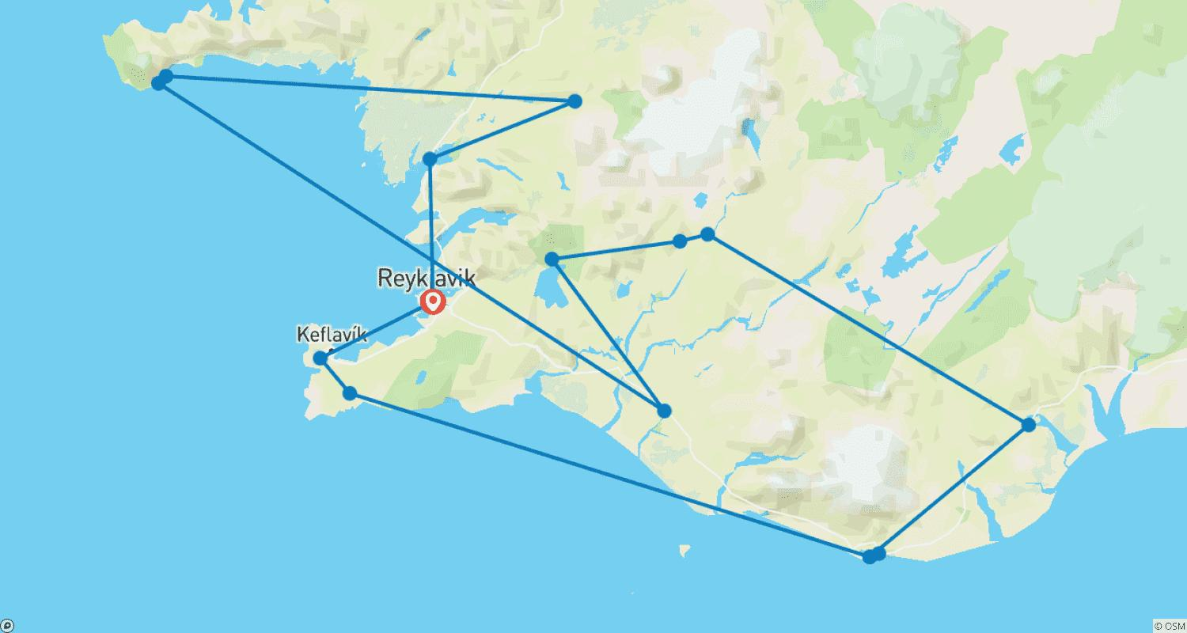

Tour ID: 256625  
Tour Name: Six Days in Iceland

Tour destinations: ['Reykjavik', 'Thingvellir National Park', 'Gullfoss', 'Jokulsarlon', 'Vik']

Tour destinations images:

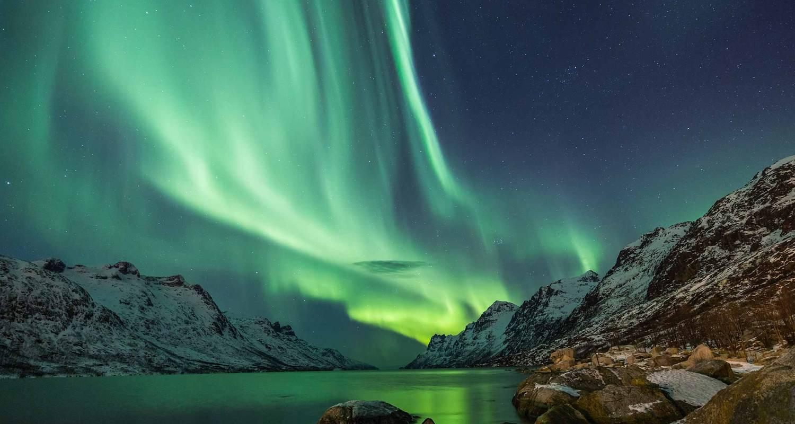

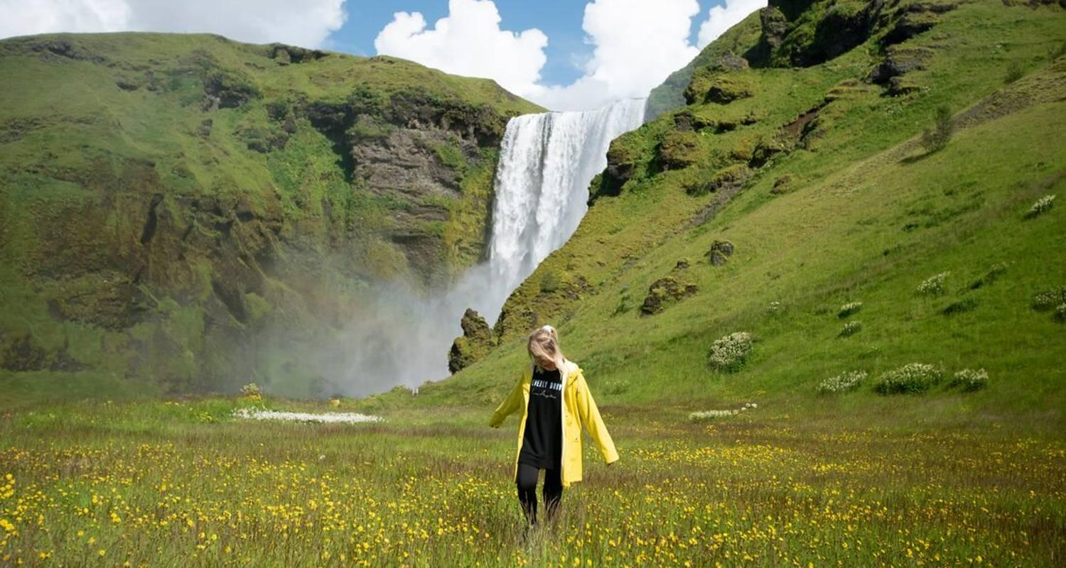

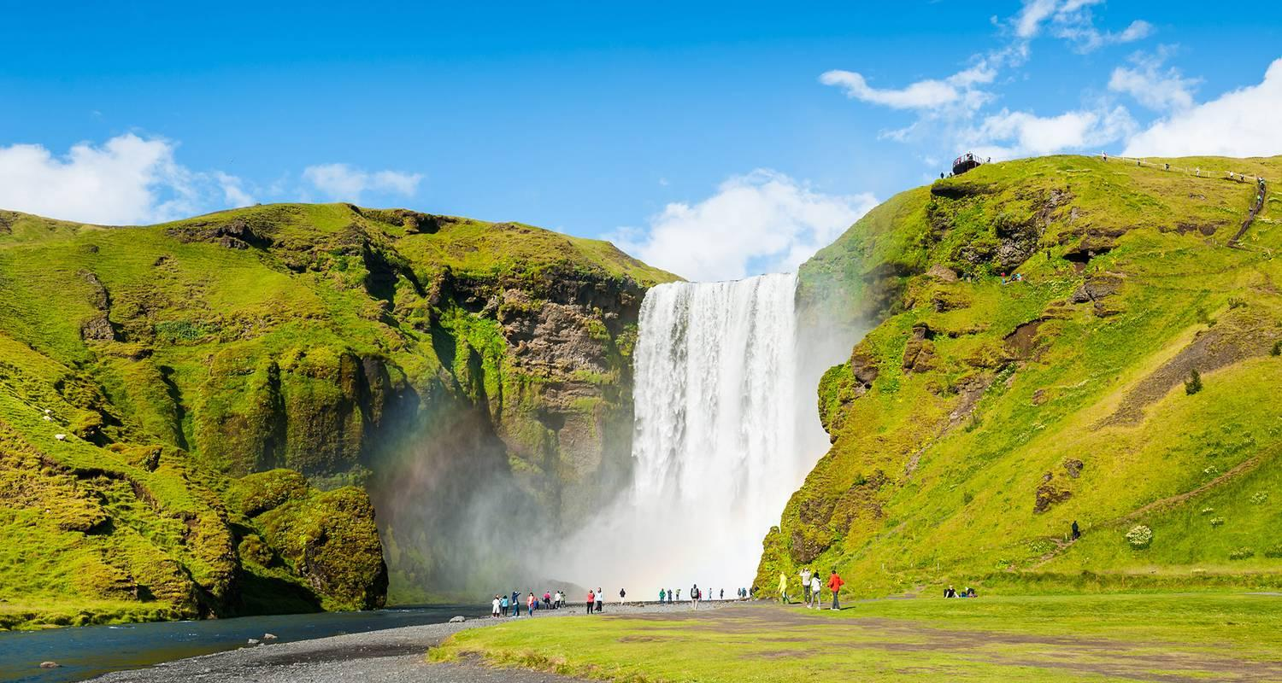

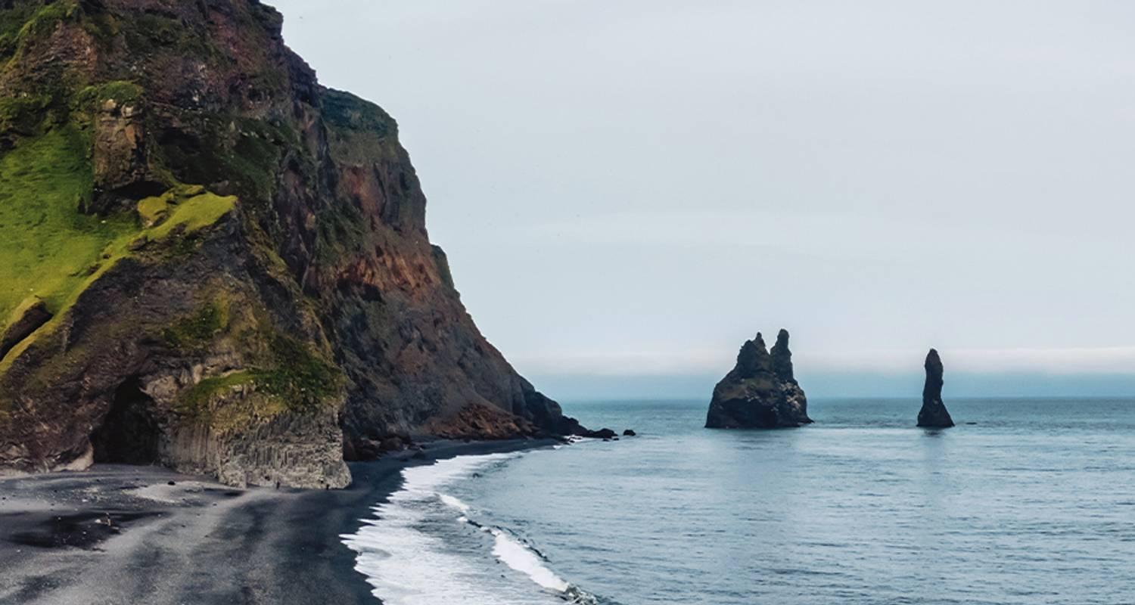

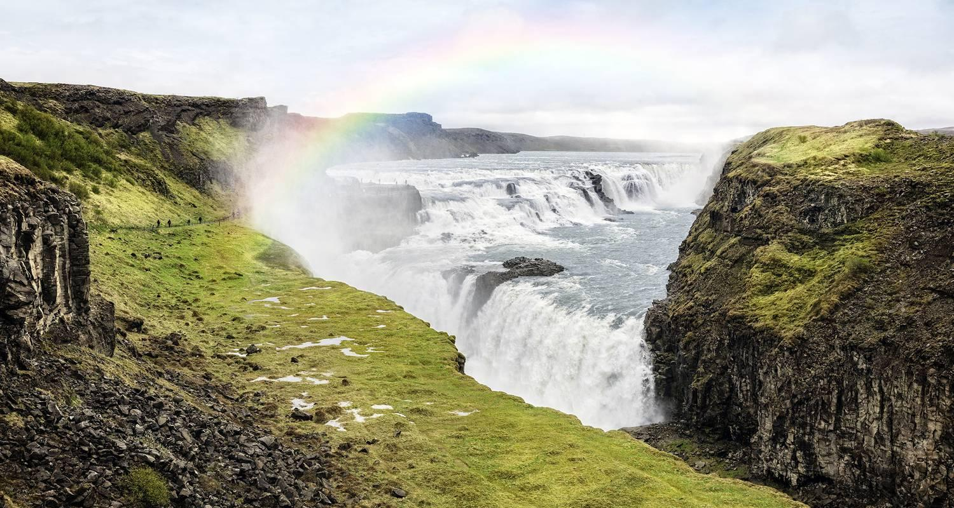

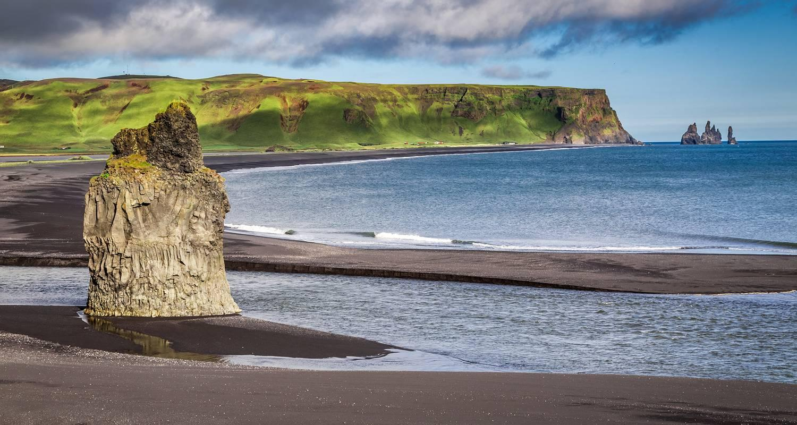

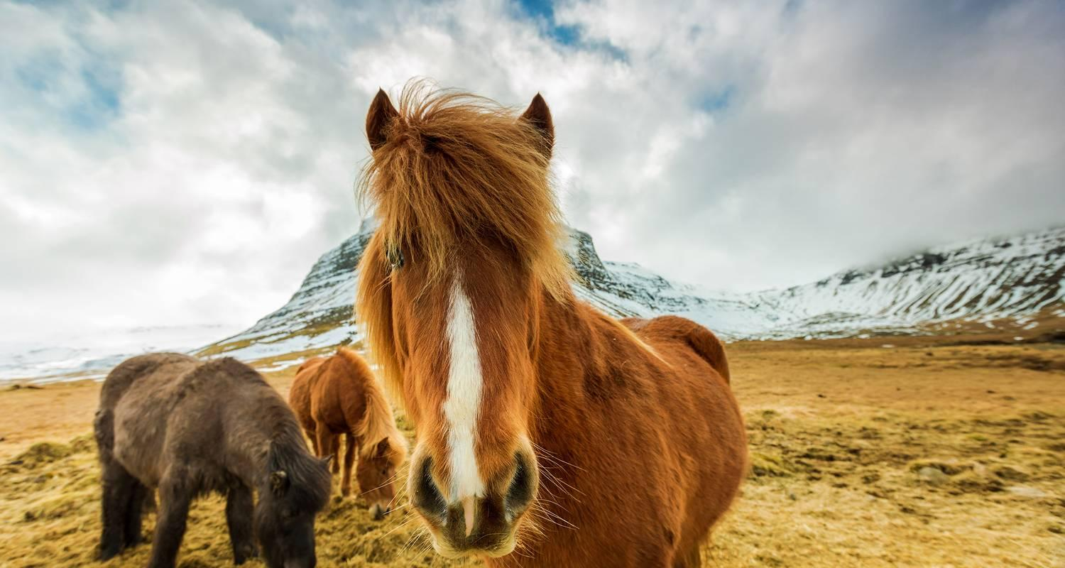

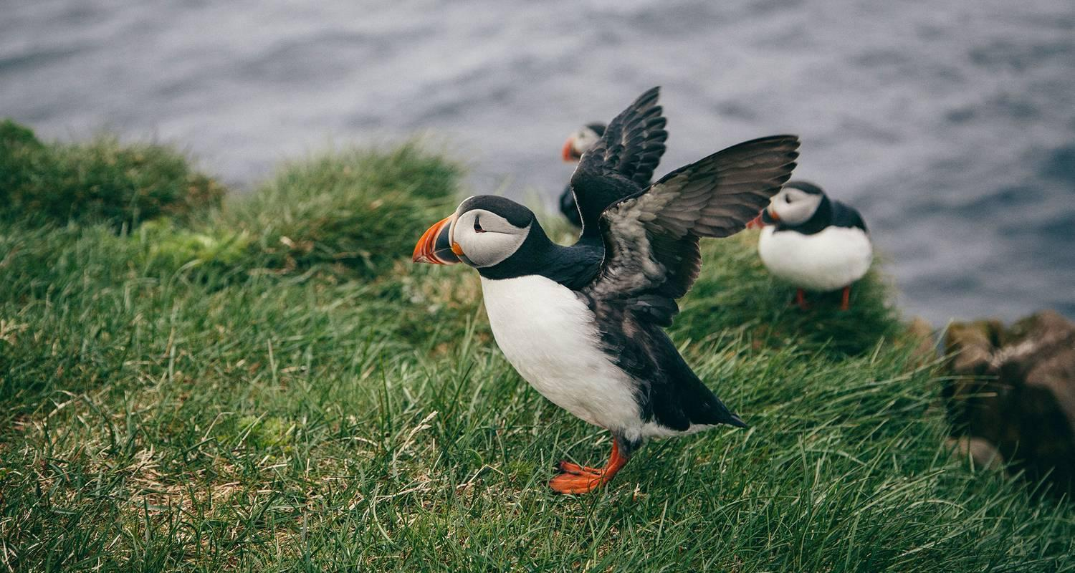

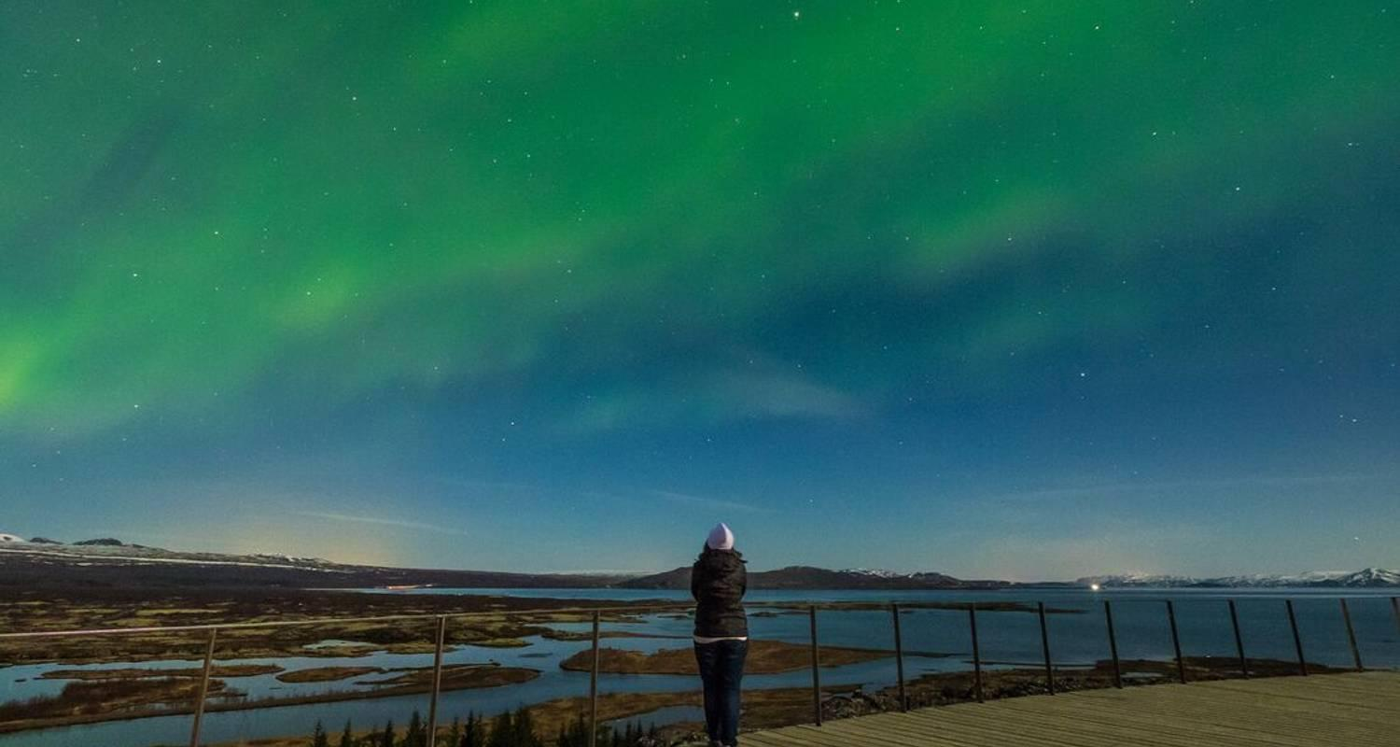

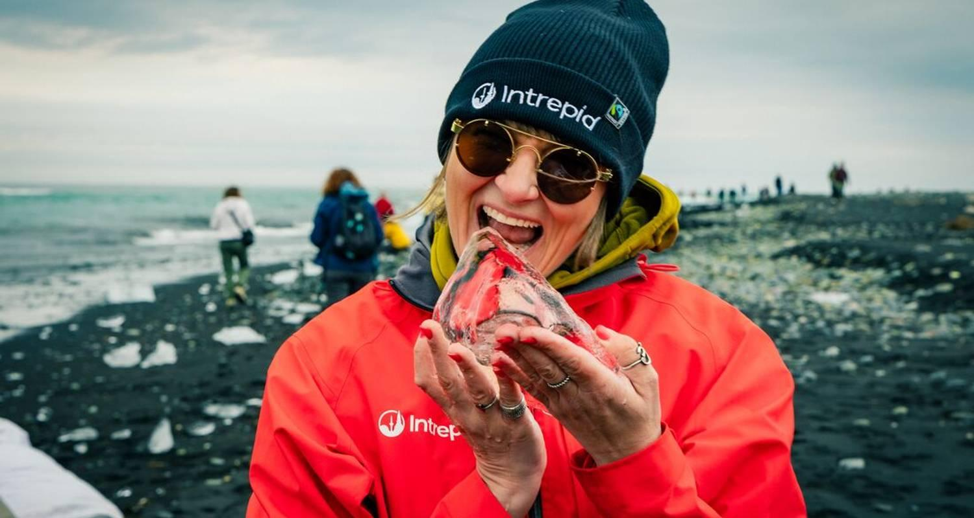

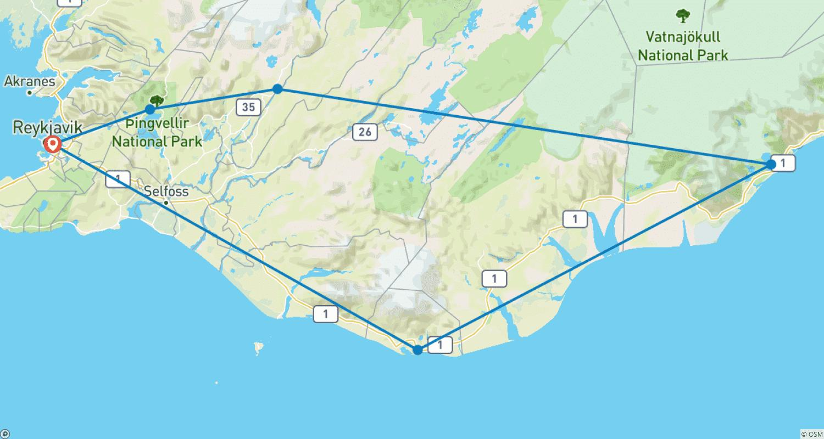

Tour ID: 257617  
Tour Name: 6 Days Ultimate Iceland Holiday

Tour destinations: ['Reykjavik', 'Skogafoss', 'Reynisfjara', 'Jokulsarlon']

Tour destinations images:

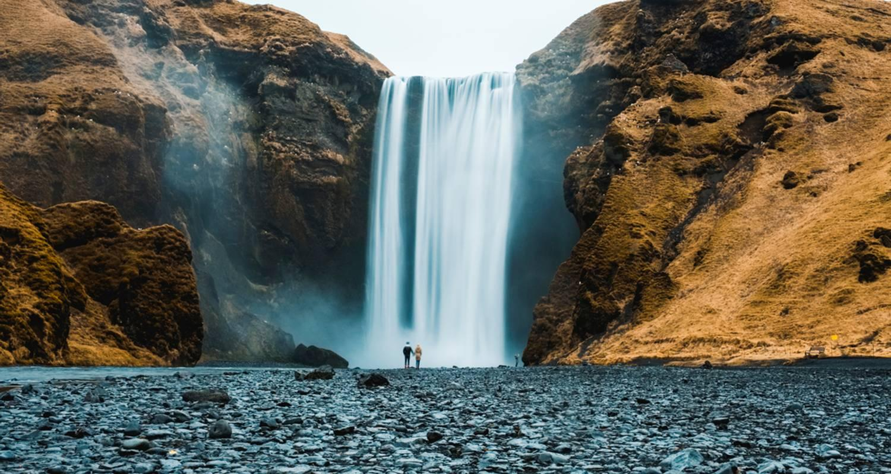

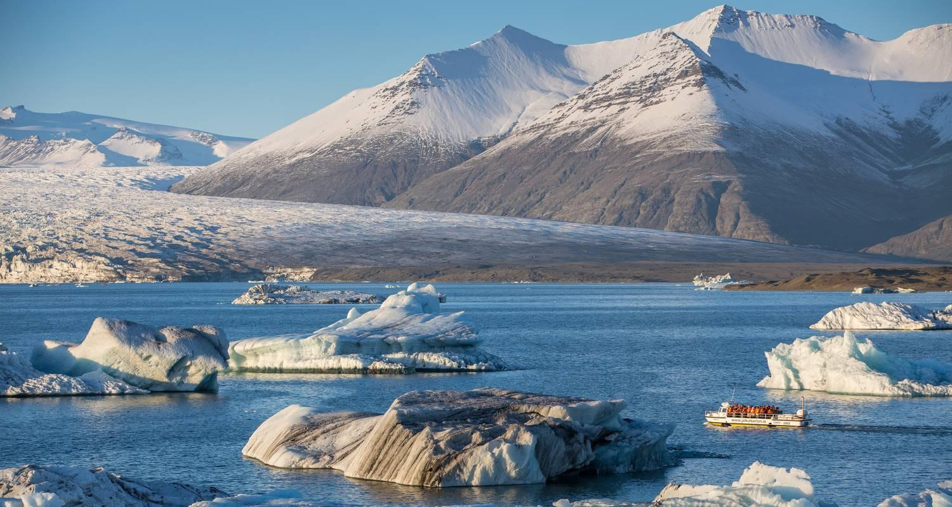

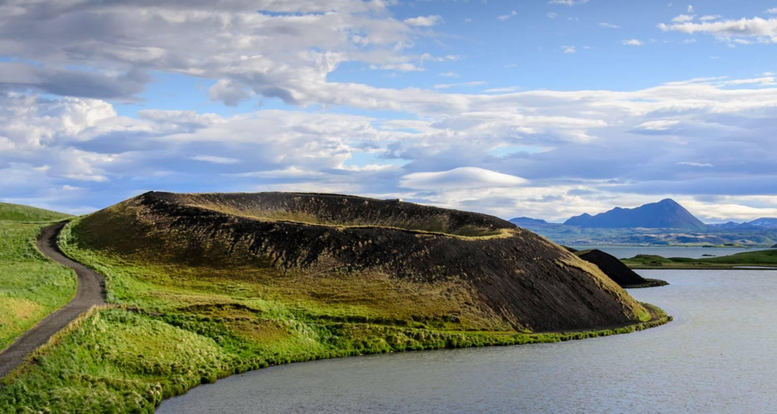

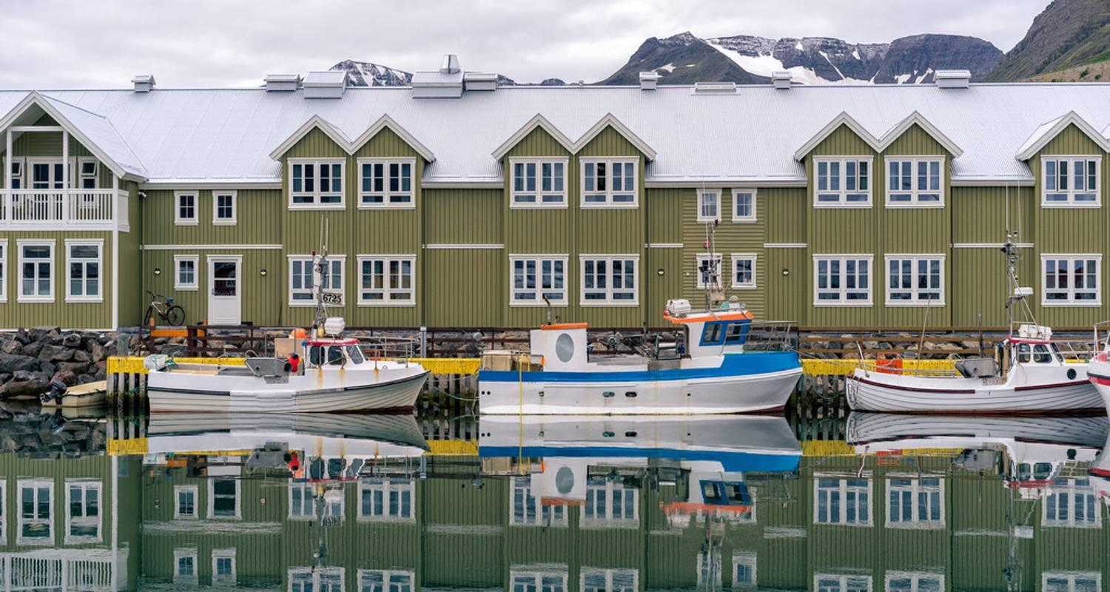

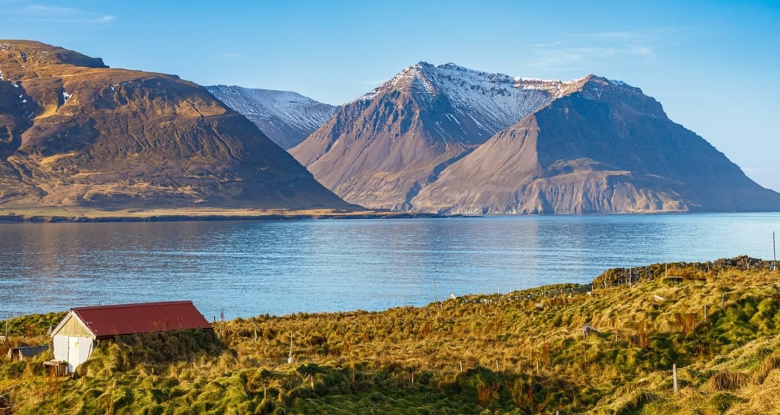

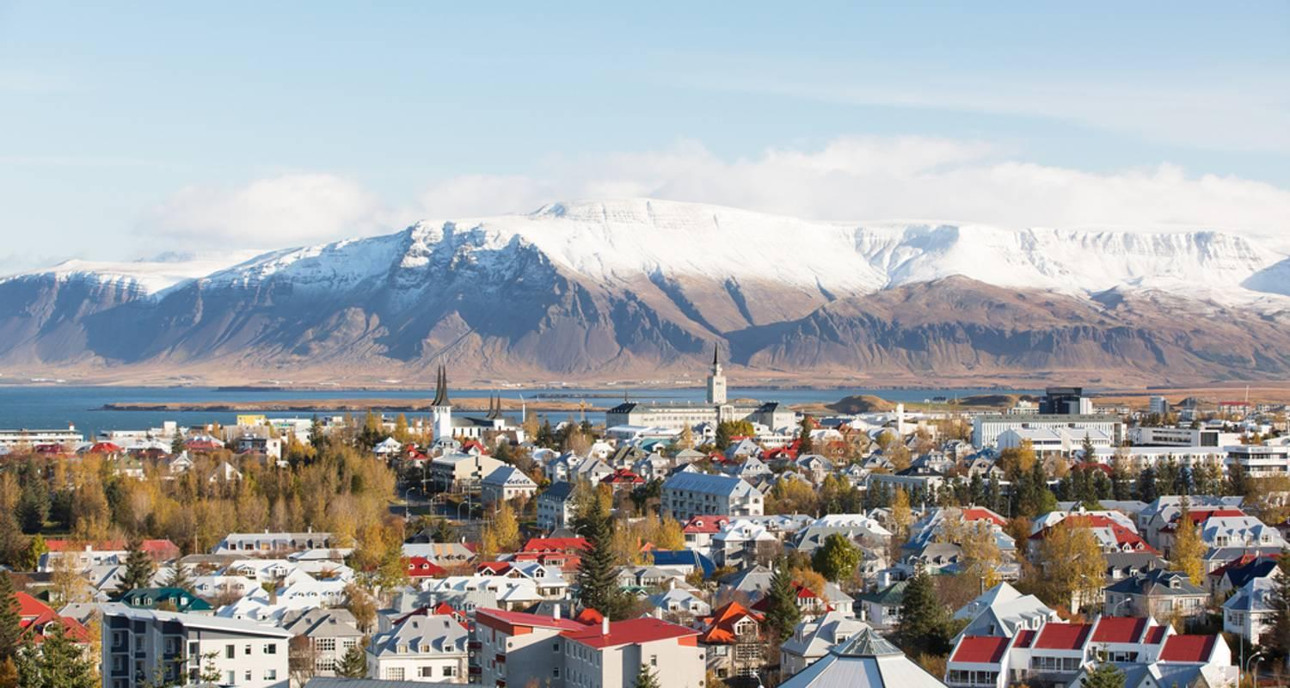

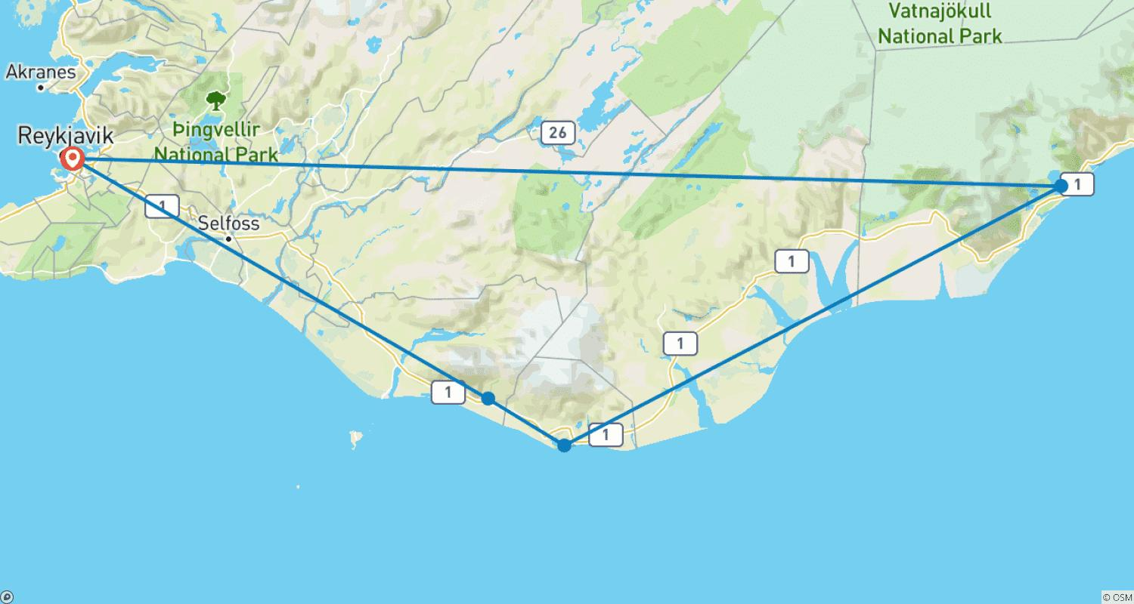

Tour ID: 257623  
Tour Name: Exploring Copenhagen Oslo and Reykjavik With Enchanting Northern Lights

Tour destinations: ['Copenhagen', 'Oslo', 'Reykjavik']

Tour destinations images:

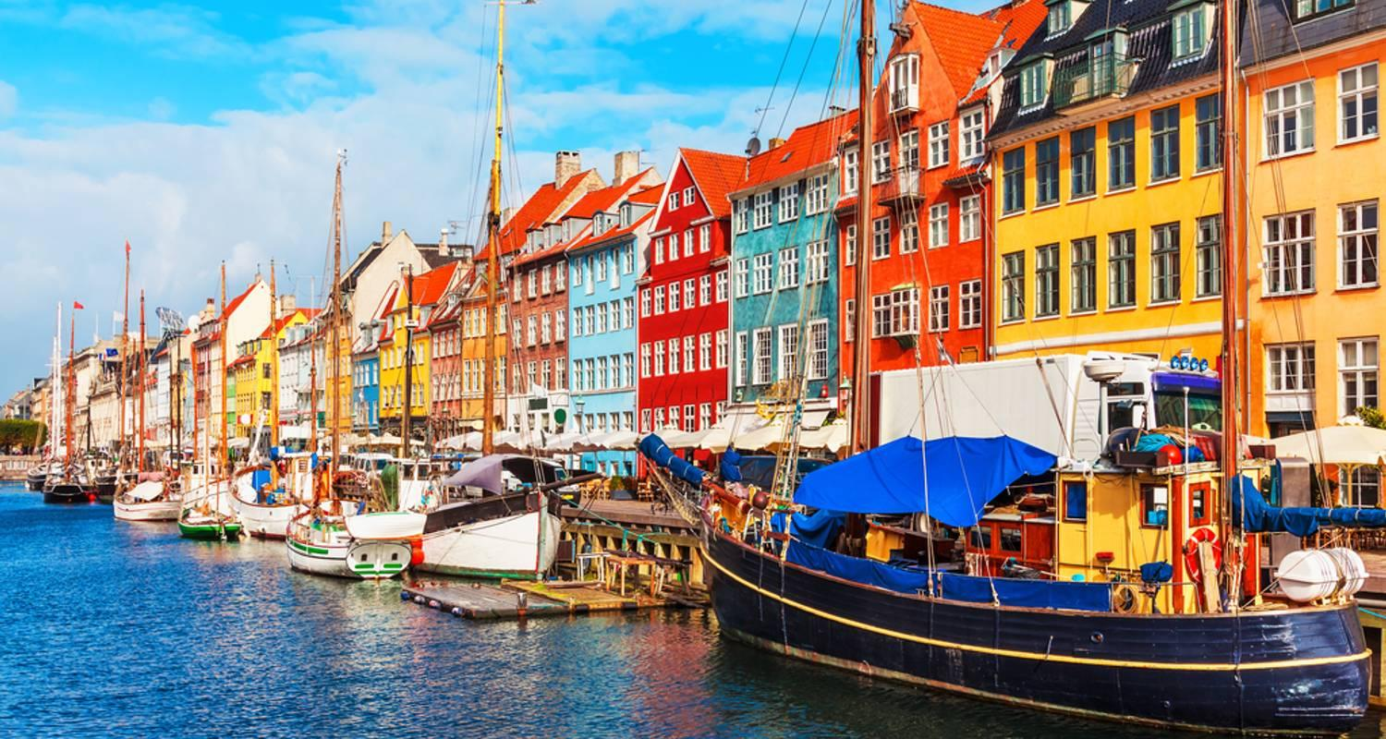

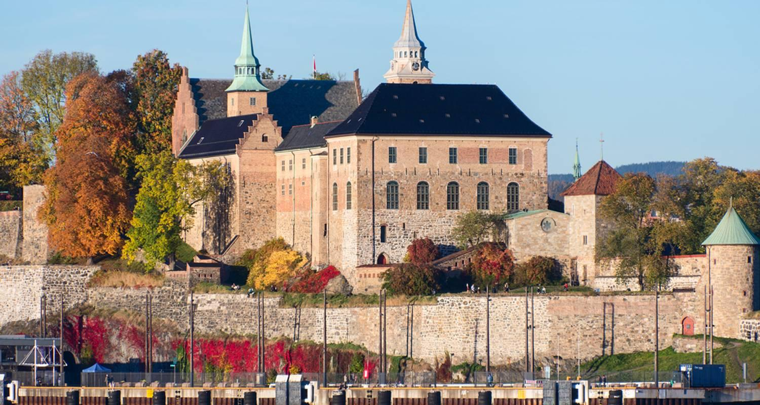

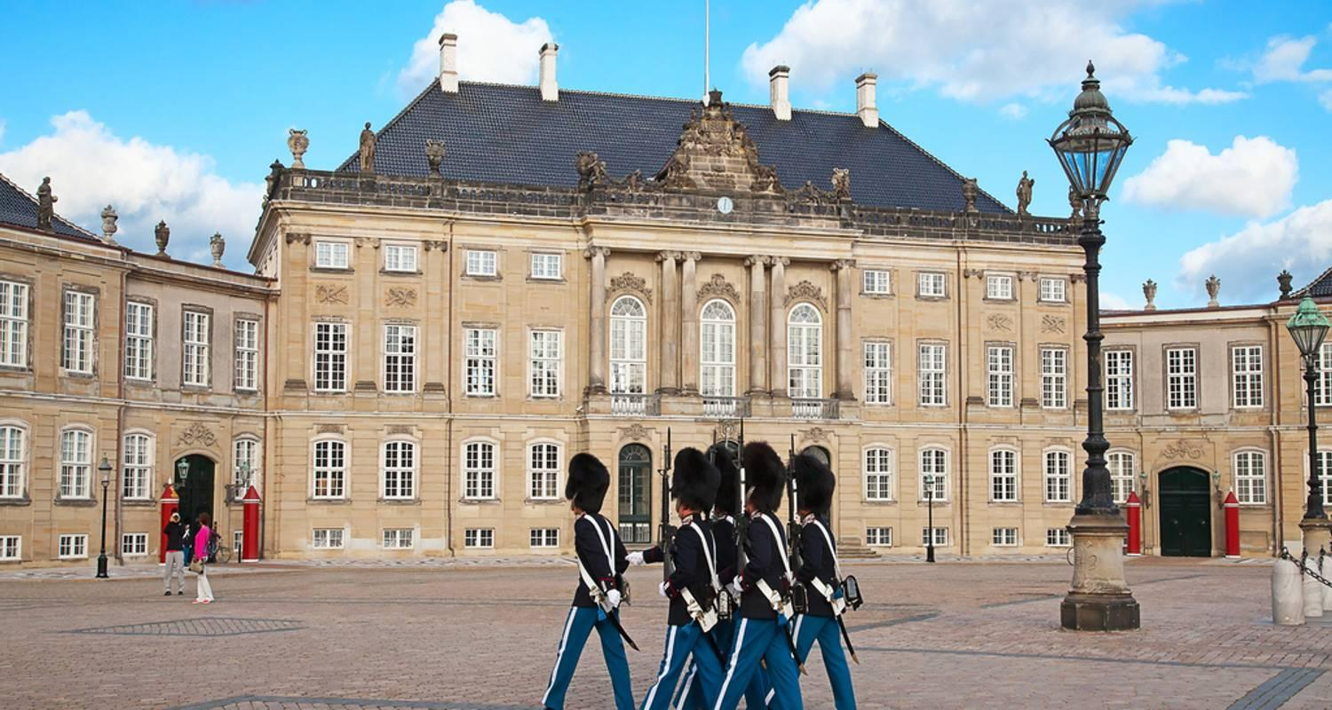

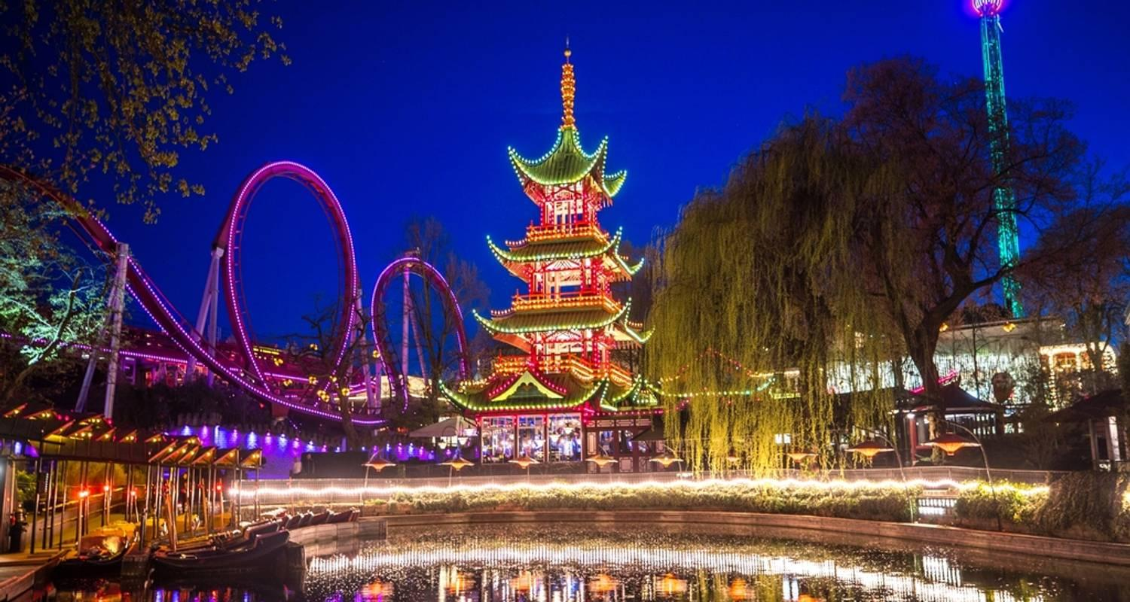

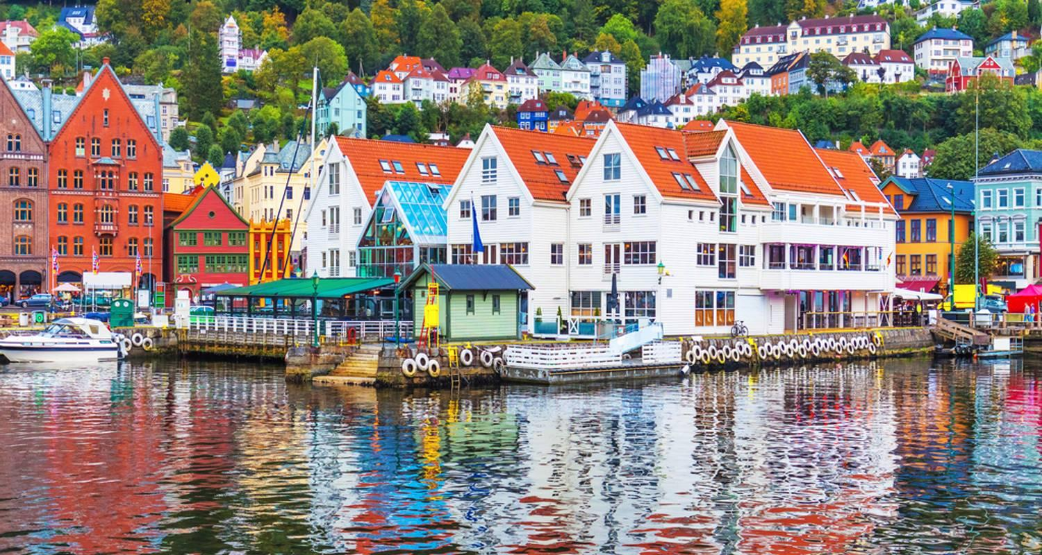

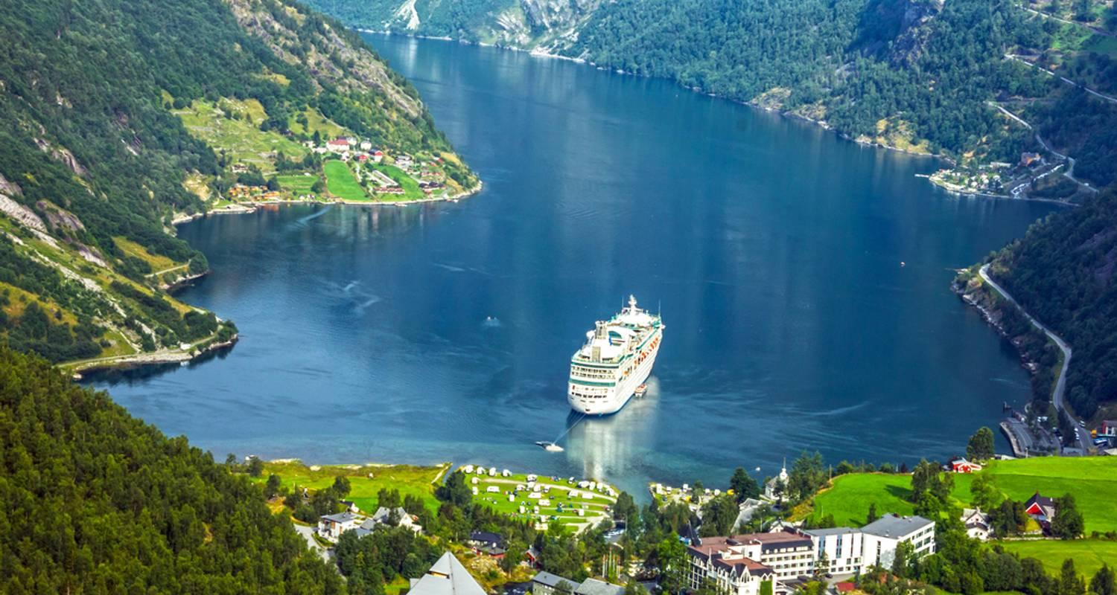



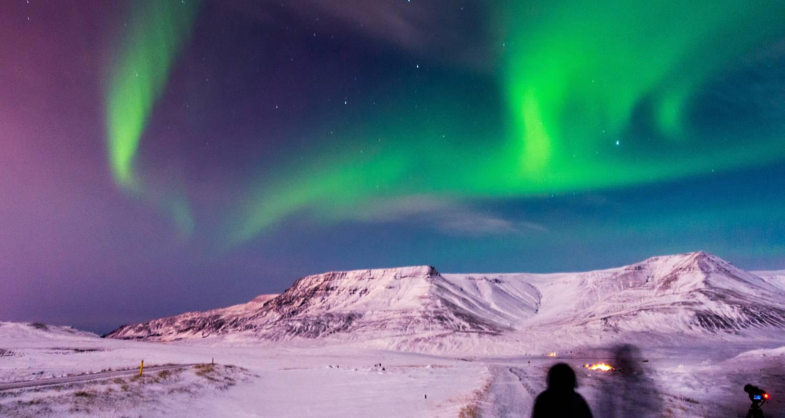

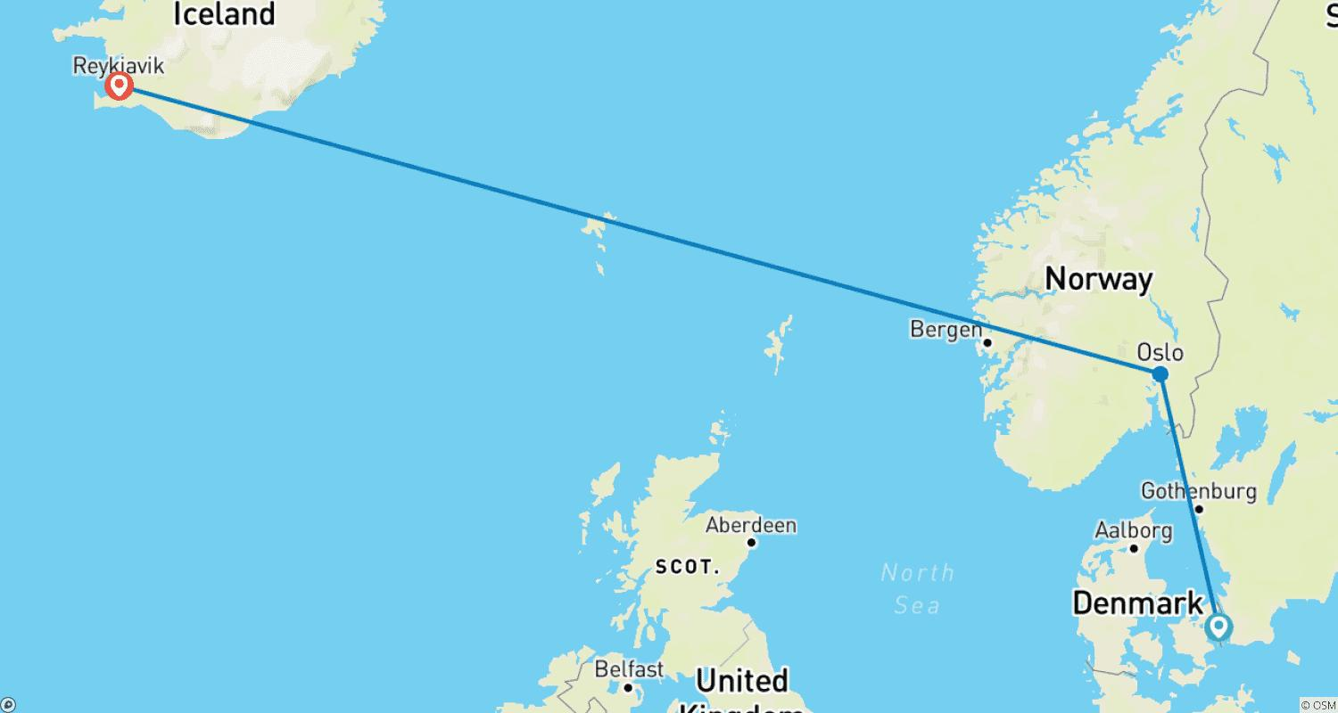

Tour ID: 257813  
Tour Name: Underway in the Baffin Sea between North America and Europe

Tour destinations: ['Keflavik', 'Kangerlussuaq', 'Kangaamiut', 'Nuuk', 'Iqaluit', 'Lower Savage Islands', 'Monumental Island', 'Lady Franklin Island', 'Pangnirtung', 'Sisimiut', 'Qeqertarsuaq', 'Ilulissat', 'Sarfannguit']

Tour destinations images:

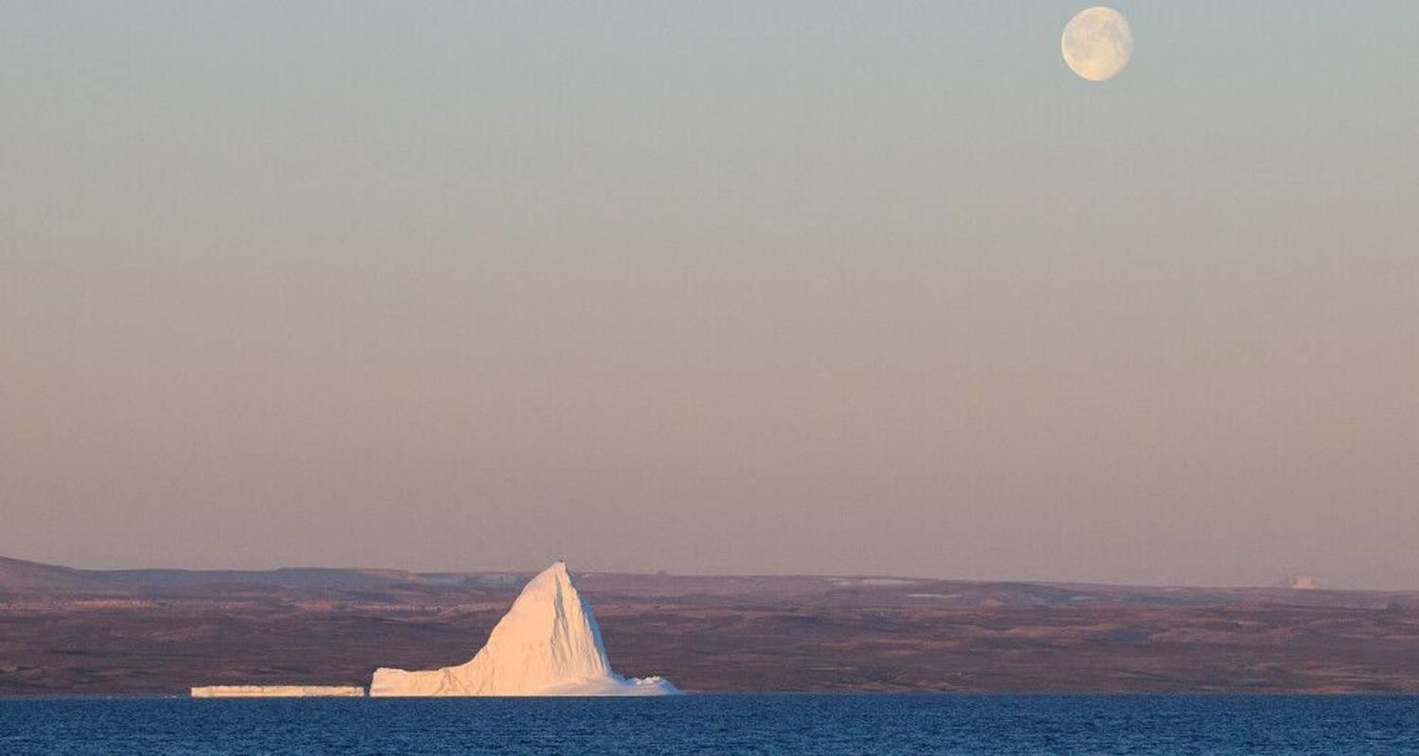

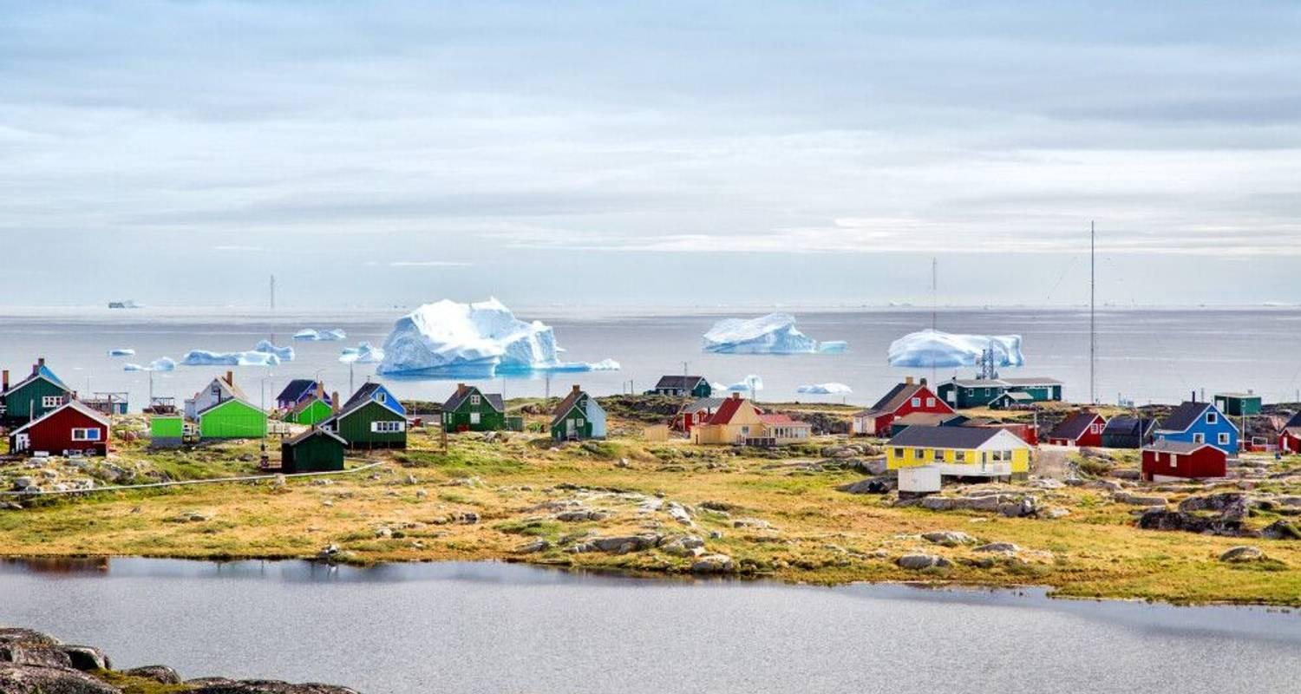

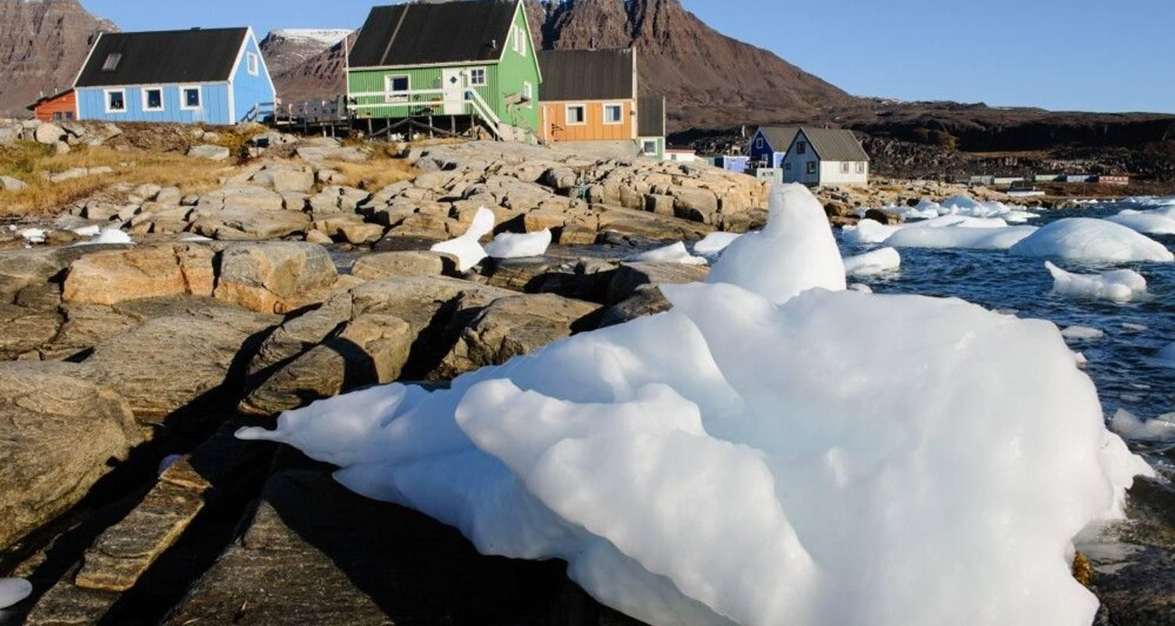

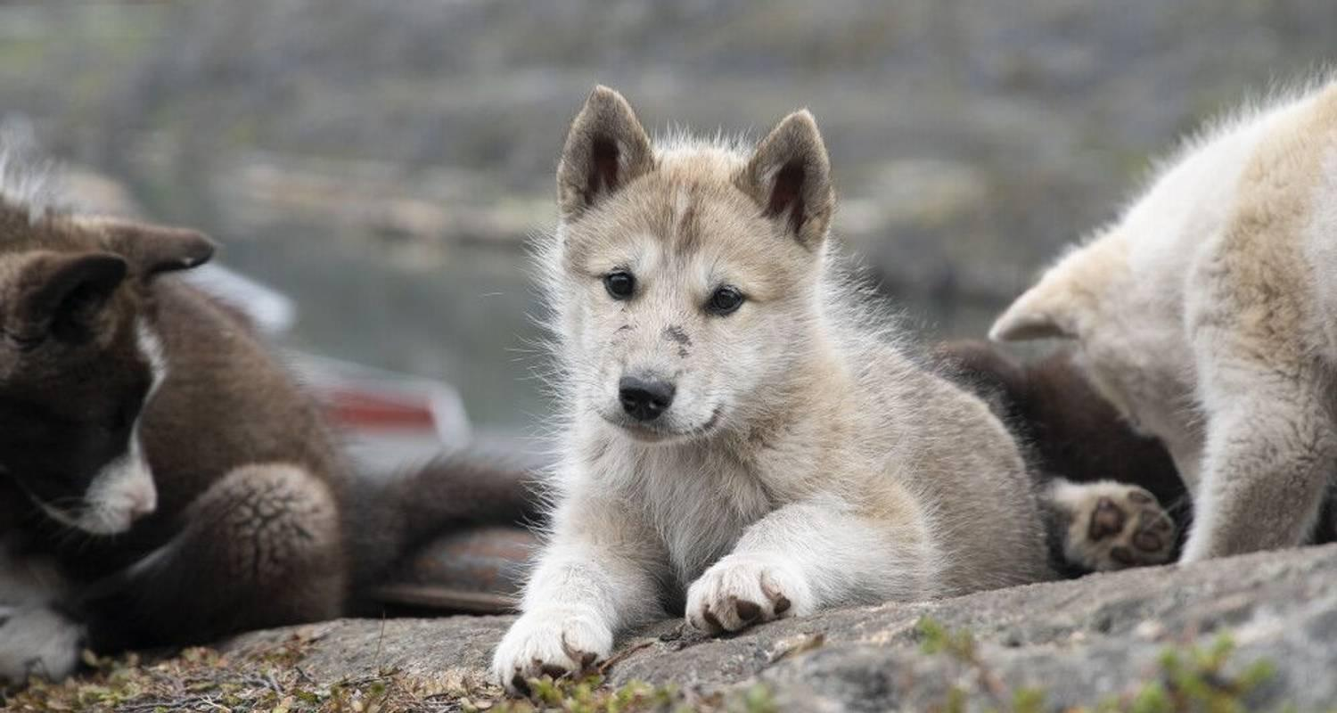

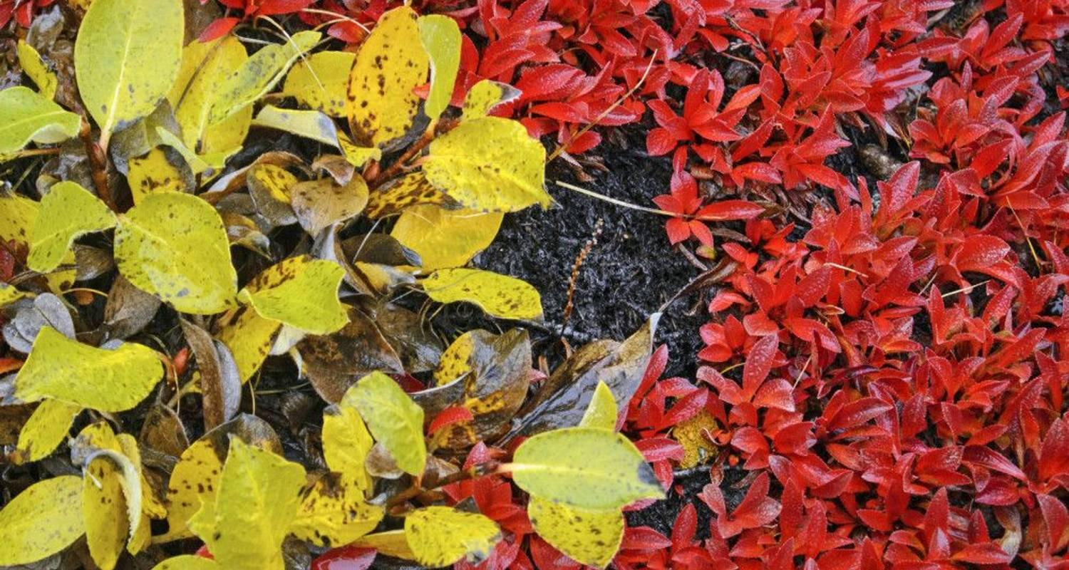

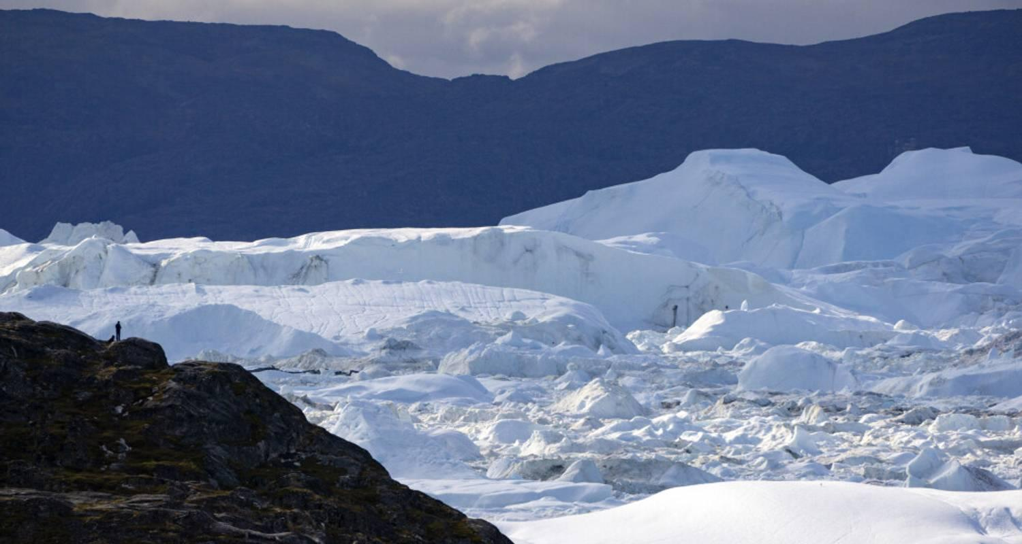

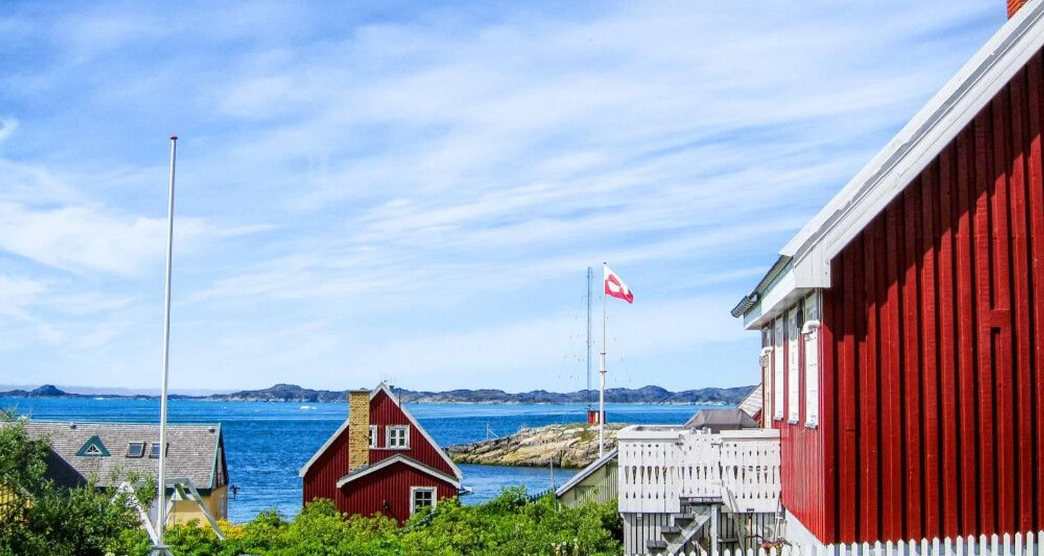

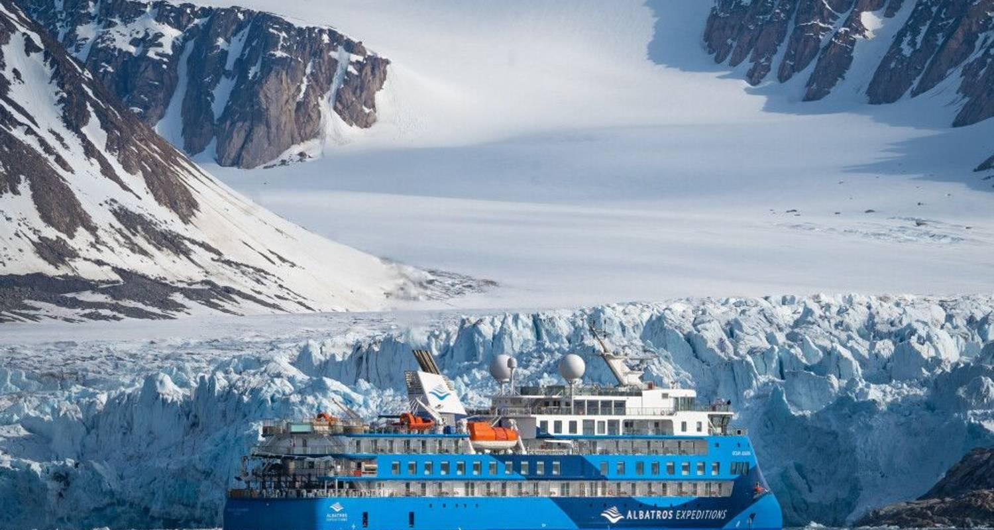

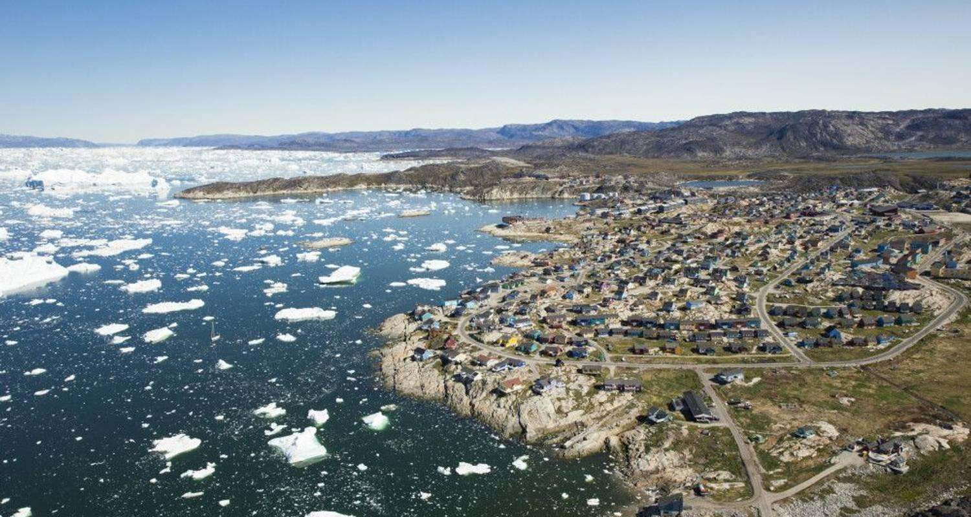

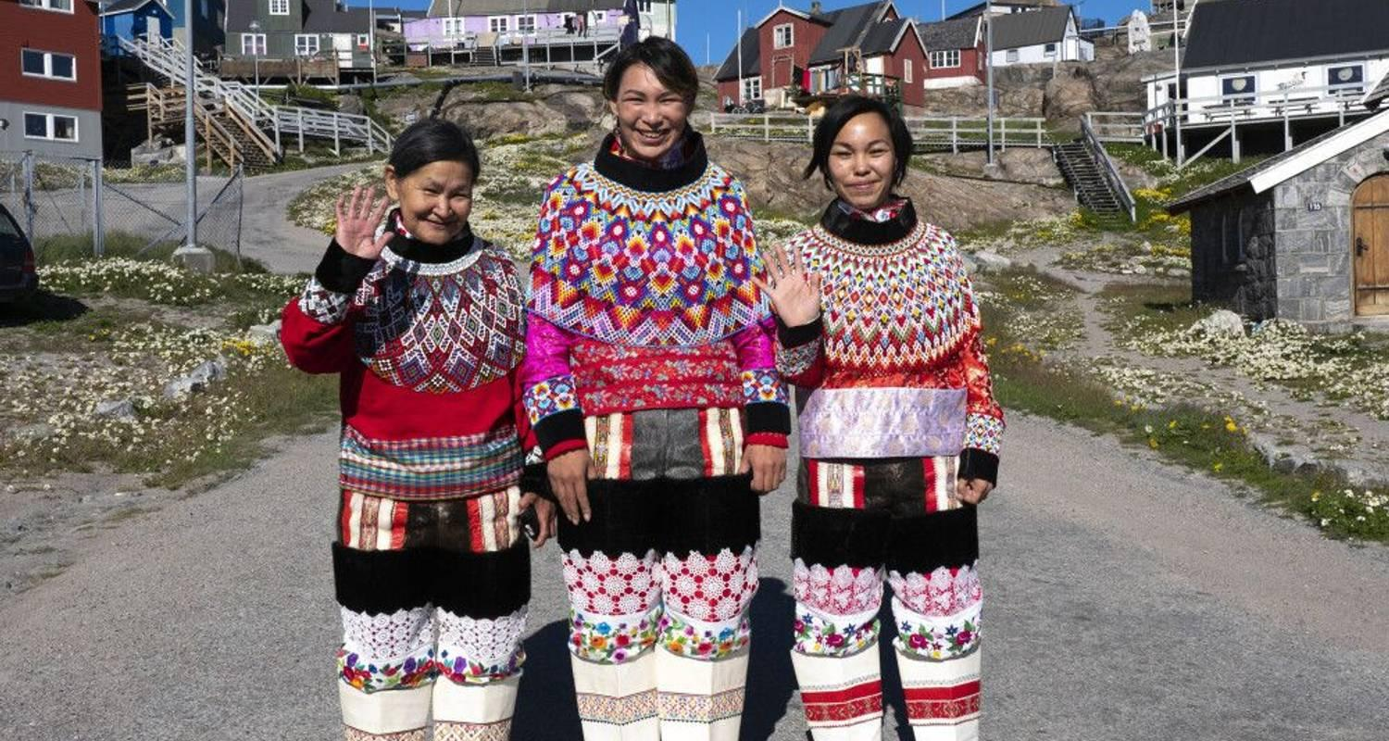

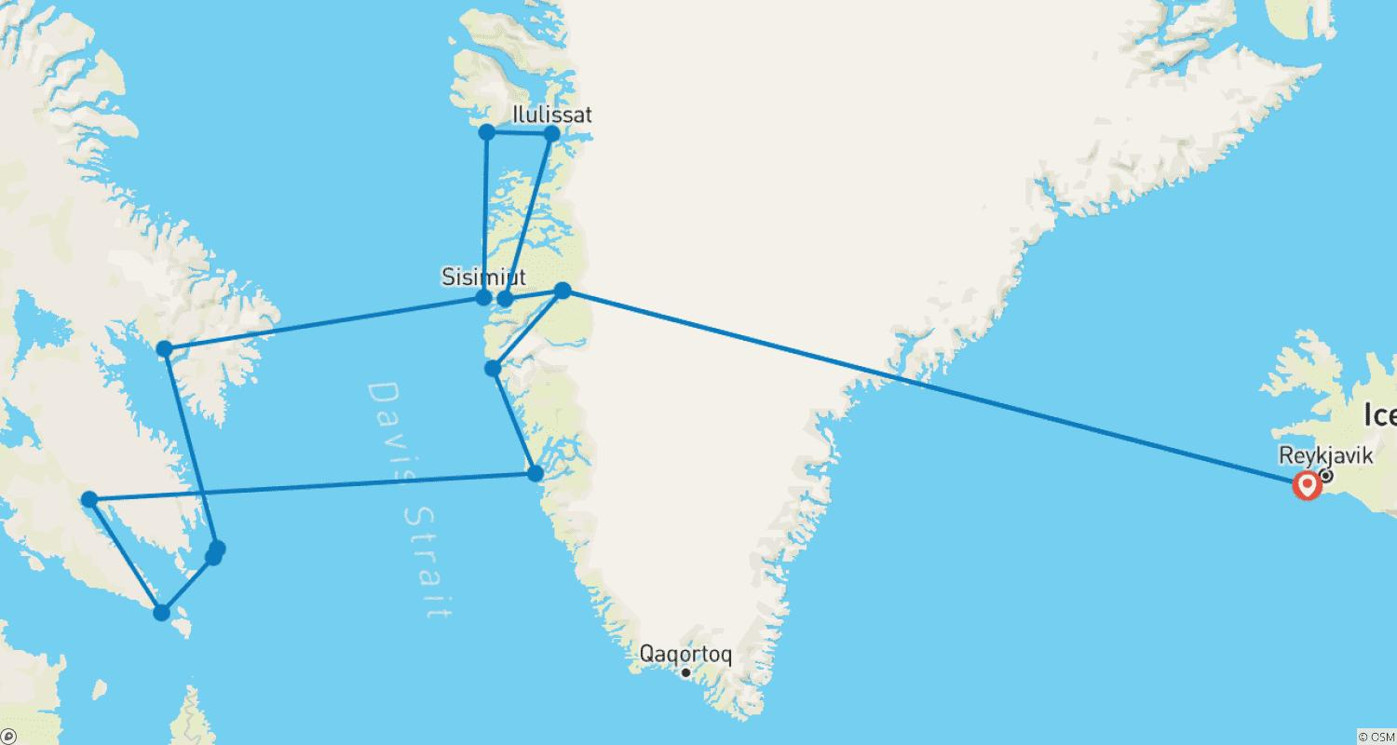

Tour ID: 257907  
Tour Name: Greenland Explorer: Sail and Soar the Alpine Arctic, Operated by Quark

Tour destinations: ['Reykjavik', 'Narsarsuaq', 'Keflavik']

Tour destinations images:

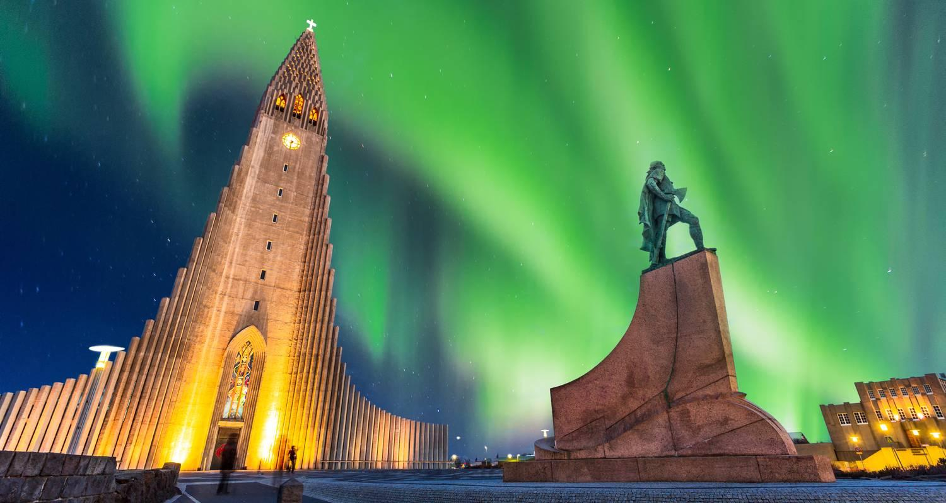

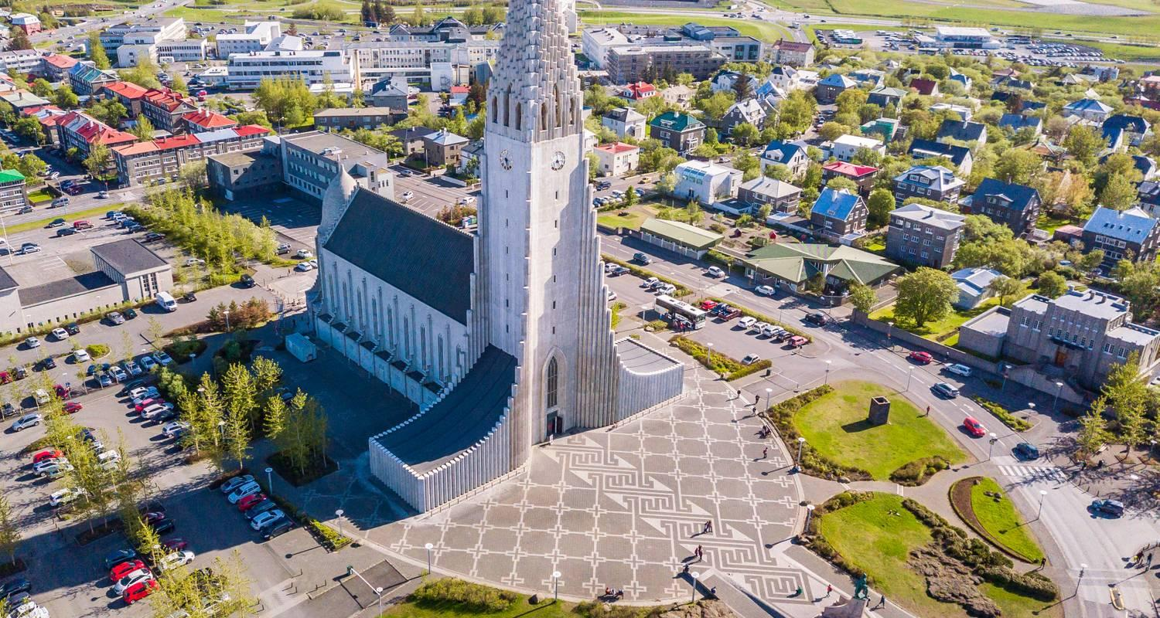

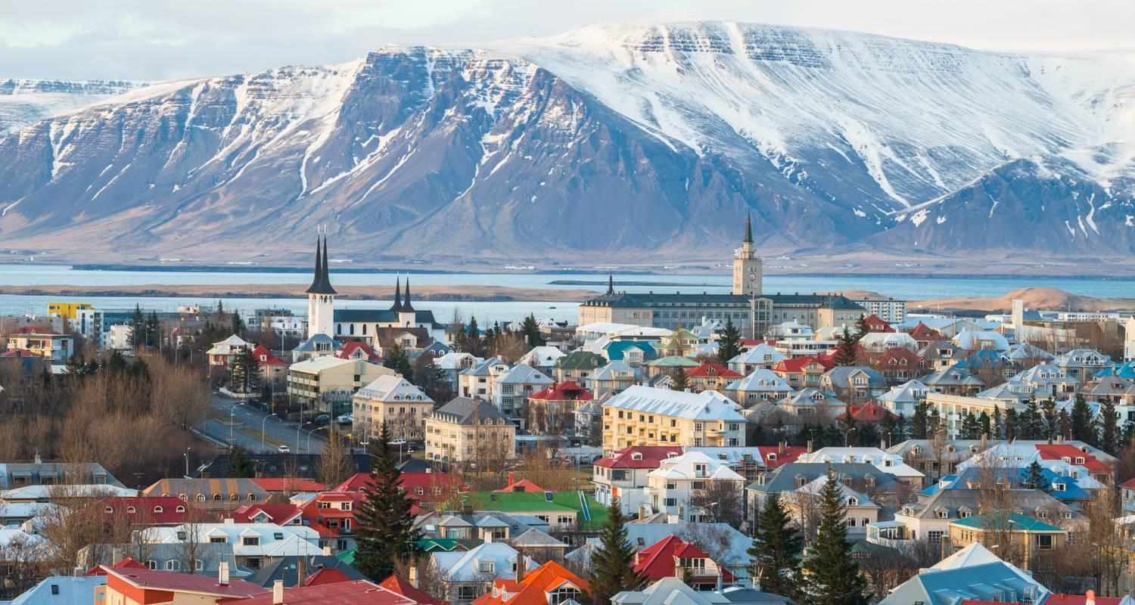

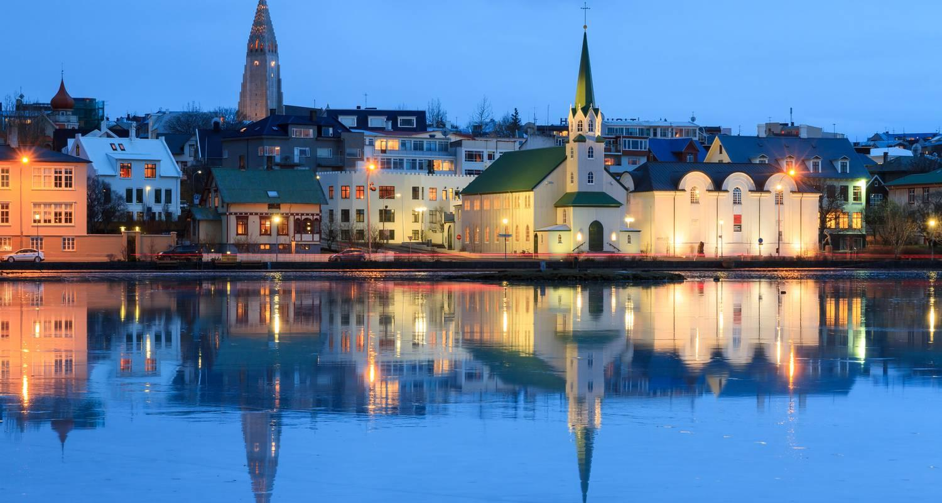

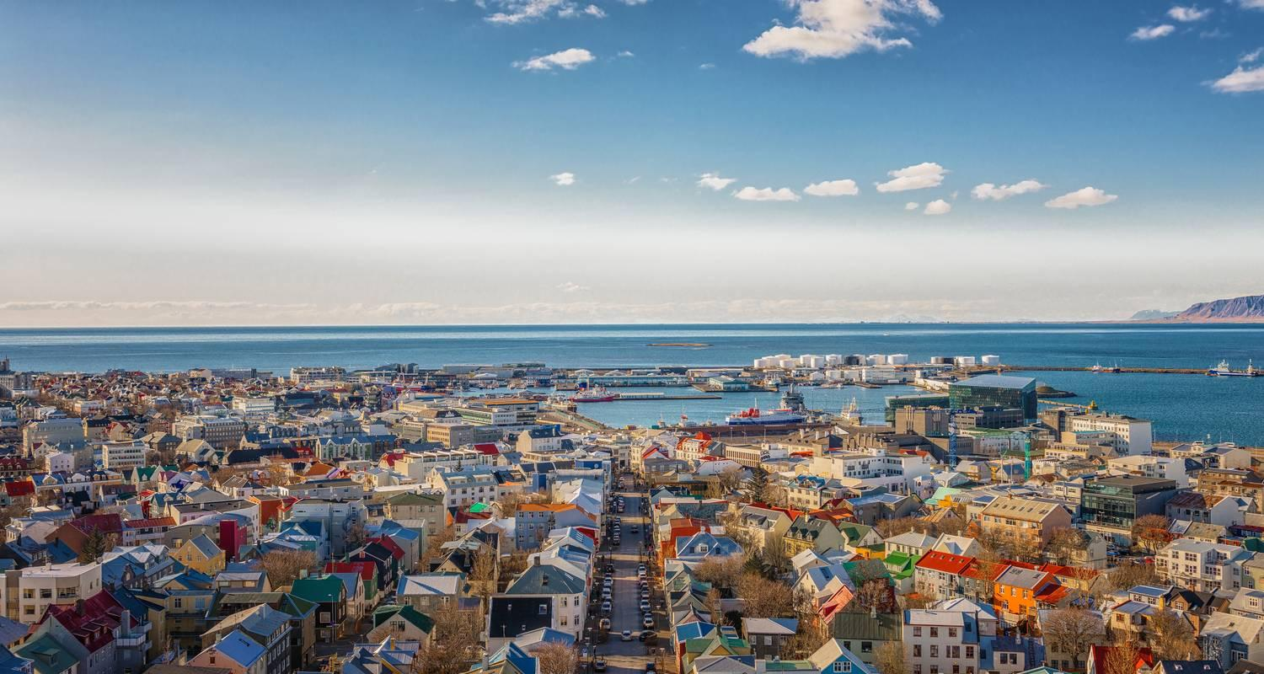

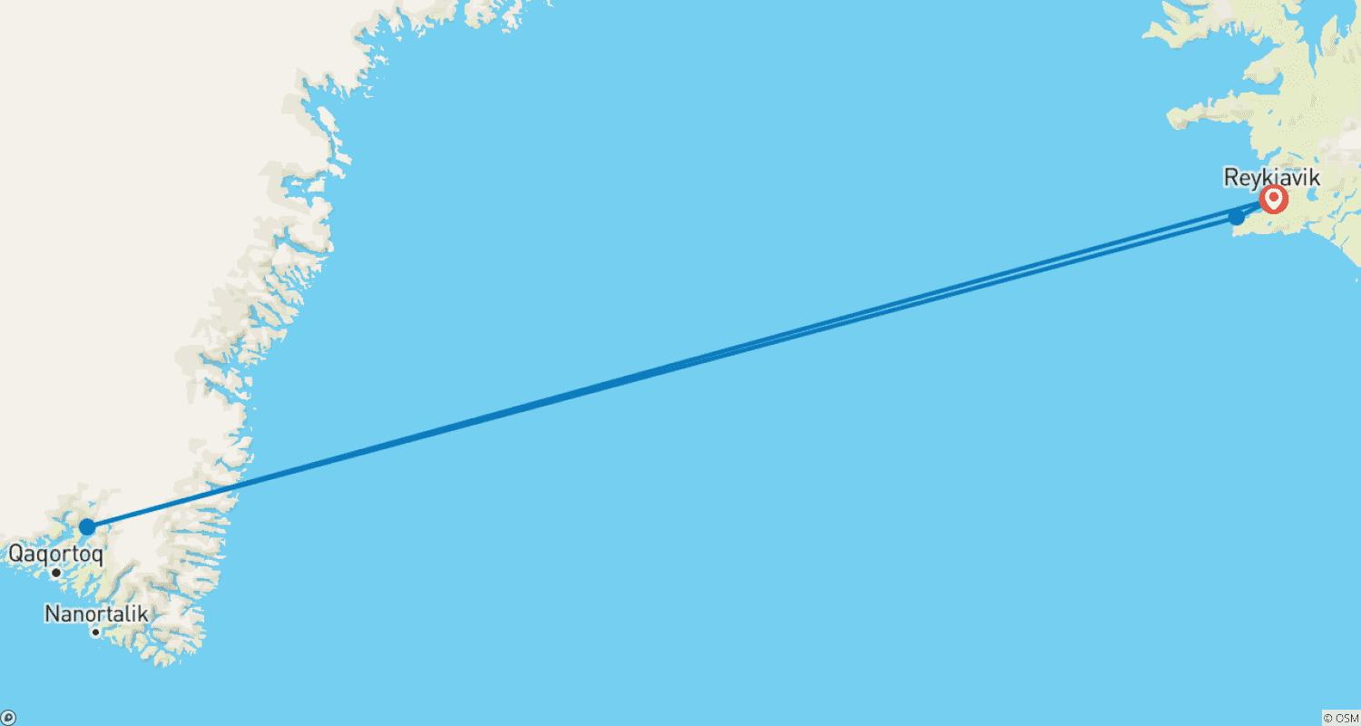

Tour ID: 258365  
Tour Name: Road trip Adventure in Iceland: Natural Forces of the Ring Road

Tour destinations: ['Keflavik', 'Selfoss', 'Gullfoss', 'Skogafoss', 'Vik', 'Vatnajokull National Park', 'Egilsstadir', 'Faskrudsfjordur', 'Akureyri', 'Reykholt', 'Reykjavik']

Tour destinations images:





